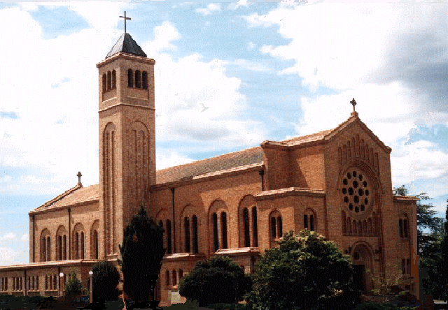
St Christopher’s Cathedral

Cnr. Canberra Avenue and Furneaux Street, FORREST ACT 2603

Parish Office: 55 Franklin Street, FORREST ACT 2603
Tel: +61 (02) 6239 9846, email: cathedral@cg.org.au
www.cg.org.au/cathedral

Acting Administrator: Fr Andrew Lotton School of Religion Coordinator – Charlotte D’Cruze

ST CHRISTOPHER’S CATHEDRAL PARISH

SACRAMENTAL PROGRAM ENROLMENT FORM 20____ (enter year)

Child’s Details:

Family Name ……………………………………. Other Names …………………………………..….…..

Date of Birth ………………………………Current School …………………………..………Grade…….

Place of Baptism ………………………………………………….…Date of Baptism…………………....
- Copy of Baptism Certificate attached

Give details of any medical/behavioural condition or allergies we need to know about your child

……………………………………………………………………………………………………………….…
Sacraments already received: Sacraments to be received in ______
- Penance (Reconciliation) Penance (Reconciliation)
- Eucharist (First Communion) Eucharist (First Communion)
- Confirmation Confirmation *
*your child must be baptised and have received the Sacraments of Reconciliation and Holy Communion prior to being Confirmed.

Parents/Guardians Details:

Father’s Full Name: …………………………………………………………Religion:……………………

Mother’s Full Name: …………………………………………………........…Religion:………………..….

Mother’s Maiden Surname: …………………………………………………………………………….……

Address ……………………………………………………………………………………………..………..
..
Telephone: (H)………………..………(W) ..………………………….(M) …...…………………….….…

Email…………………………………………………………………………………………………………...

We commit ourselves to prepare our child for the Sacrament of ……………………………………by
coming to meetings; celebrating Sunday Eucharist; see that our child attends all lessons and completed work at home; pray as a family; present our child to receive the Sacrament of Reconciliation on a regular basis.

______________________________________ ____________________________________
Father’s Signature Mother’s Signature

(Payment details on reverse side)

Payment Details:

Return this form with a donation of $25.00* (Cheques: ‘St Christopher’s Cathedral Parish’) and a copy of your child’s Baptismal Certificate marked to the attention of Michelle O’Connor, Parish Secretary.

*This money is requested to assist the Church in paying for the workbooks, teaching texts, medallions, stoles, candles and certificates. Please speak with Fr Andrew Lotton should you have any concerns in making this payment.

Payment can be made either by online payments: https://www.bpoint.com.au/payments/sccp,
Direct Bank Transfer, credit card payment either in person at this office, cash or cheque (made out to St Christopher’s Parish). For bank transfer, our banking details are as follows:

Account Name: St Christopher’s Cathedral
Bank: Commonwealth, Manuka
BSB Number: 062786
Account Number: 15080

Please put in your banking reference your surname/’sacrament name’ (eg: Jones Confirmation or Holy Communion or Reconciliation 4.8.18). Please email a copy of the banking receipt to this office so your payment can be recorded.

