PARISH INFORMATION

Reconciliation (*Confession*)

Merimbula: Friday, after Mass,

Eden: Sat., before Vigil Mass,

Wednesday, after Mass, Pambula

Anointing of the Sick: Last Friday

Merimbula: 31 January. 10.00 am

Pambula: 28 Feb. 10.00 am

Eden: 27 March. 10.00 am

Sacrament of Baptism

Welcoming Mass – 4th Sat/Sun

of the month prior to Baptism during Mass on 1st Saturday/Sunday of the

month. Please call office for all Baptism preparation enquiries.

Weddings

By appointment only – at least 6 months’ notice in advance.

Adoration

Thursday 9:00am followed by Mass at 10.00 am, Eden

Divine Mercy Chaplet & Rosary

Sun 9:30am Merimbula

Fri 9:30am Merimbula

Rosary

Monday Cenacle

11am Merimbula

Wednesday 9:30am Pambula



Contact Details

Parish Priest

Fr George Ogah

[George.Ogah@cg.org.au](mailto:George.Ogah@cg.org.au)

Phone: 0435 036 236

Parish Council Chair

Mrs Bernadette Wood

Liturgy Coordinator

Ms Sue Heffernan

Finance Chair

Mr Neil Ffrench

Parish Safeguarding Volunteer

Mr Philip Roach

[pambula.safeguarding@cg.org.au](mailto:pambula.safeguarding@cg.org.au)

Lumen Christi Catholic College

Mr Shane Giles (02) 6495 8888

Parish Office

**Currently closed**

Phone -0435 036 236

-(02) 6495 0683

Email: pambula@cg.org.au

Web - www.cg.org.au/pambula

Address: 79 Main Street / PO Box 249, Merimbula, NSW, 2548

Churches

Our Lady Star of the Sea, Eden

St Joseph’s, Merimbula

St Peter’s, Pambula

Mass Times

Saturday 6pm, Eden

Sunday 8am Pambula

10am, Merimbula

Tuesday 5pm, Merimbula

Wednesday 10am, Pambula

Thursday 10am, Eden

Friday 10am, Merimbula

St Peter’s Catholic Parish

Our mission as a Christian community of St. Peter’s Parish is enlightened and inspired by the Holy Spirit, is to be salt and light through the loving way of our words, actions and respect for the dignity of all, so that others may experience the love of Christ.

We acknowledge the Yuin people and pay our deepest respect to elders past, present and emerging from all first nations of the world from whom we have learned so much

**COMING EVENTS**

**AGED CARE FACILITY MASSES**

13th Feb. 11.15am Imlay House, Pambula

4th March 2.00pm Albert Moore Merimbula

6th March 11.15am Uniting Care, Eden

**Lumen Christi College**

14th Feb. 11:30am Opening Mass-Induction of 2025 Captians.

**Liturgy Committee Meeting**

11th Feb. 7:00pm Merimbula

**Ash Wednesday Masses**

5th March10.00am Pambula

5.30pm Merimbula

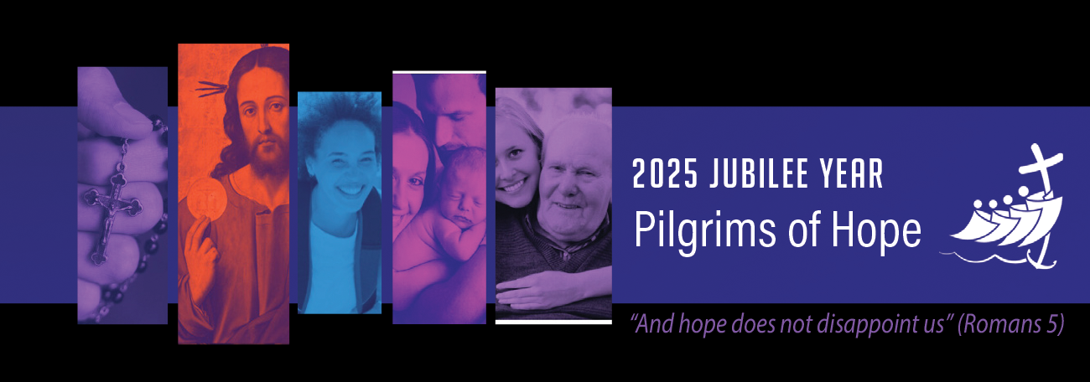

P

P

*This Year of Jubilee in the universal Church calls us to embrace, and be renewed in, the hope of Christ—a hope that does not disappoint. We are embarking on a particular time of pilgrimage, and as the Holy Father has reminded us, Jesus, ‘is the destination of our pilgrimage’. He is both the way, and the path to be travelled.*

**Solemnities and Feasts Days**

**10th Feb. St. Scholastica (Mem)**

**14th Feb. St. Cyril and Methodius (Mem)**

**22nd Feb. St. Peter’s Chair (Feast)**

**5th March Ash Wednesday**

We pray for all the faithful departed or whose anniversaries occur including: Rosa and Mike Novinc, Joy Jansen

Let us pray for and support those who are sick and for all who have asked for our prayers: Sr Quintilia, Henk Westerlaken, Elaine Carter, Damien Lambourn, Baby Olive Delves, Josephine Power, Helen Lynch, John Hazell, Christian Cole, Pat Wong, John Liston, Conrad De Zwart, Jake Alcock, Anne Cooper, Jocelyn Petty, Monica Paffen, Glen Alcock, Patricia May Bills, Cliff Hamilton, Margot Neilson, Rob Francis, Chris Greenwood, Margaret Coates, Lyn Collie, Geoff Heffernan, Judy Broddrick, Ros Beveridge, Eric Mangion, Anselmo Guiffre, David Went.

**Position Vacant**

Interested applicants are invited to apply for Permanent Part Time Parish Secretary position for St. Peters Parish Pambula. 12 hours a week. Application Closes on 14th February, 2025. For more information, contact Fr. George Ogah.

**FOR SALE**

**Church Pews for sale.Interested?**

**Contact Fr. George Ogah**

**PARISH PILGRIMAGE**

Places are still available to people to register for the Pilgrimage. Please contact Father George.

**PARISH SAFEGUARDING COMMITMENT**: St Peter’s Parish is committed to safeguarding and upholding the dignity and rights of all children and vulnerable people. We seek to empower children, their families and carers, and vulnerable people to have their say, to be listened to and to be protected. This approach is at the centre of all of our thinking.

**COMMUNICATING CONCERNS:** You are encouraged to raise any concerns by emailing Fr George, the Parish Office, the Parish Safeguarding Volunteer or directly to Maria Hicks at the Institute Professional Standards & Safeguarding (IPSS) on ipss@cg.org.au

Planned Giving Collections:

Will be updated in the New Year. THANK YOU to ALL parishioners who continually support our Parish through our plate collections at Mass, through the envelopes and direct banking. Without your financial help our Parish could not continue to function.