

**THE TWENTY SECOND SUNDAY IN ORDINARY TIME / YEAR C, 31st August 2025**

**15 JUNE 2025**

|  |  |  |  |  |  |  |  |  |  |  |  |  |  |  |  |  |  |  |  |  |  |  |  |  |  |  |  |  |  |  |  |  |  |  |  |  |  |  |  |  |  |  |  |  |  |  |  |  |  |  |  |  |  |  |  |  |  |  |  |  |  |  |  |  |  |
| --- | --- | --- | --- | --- | --- | --- | --- | --- | --- | --- | --- | --- | --- | --- | --- | --- | --- | --- | --- | --- | --- | --- | --- | --- | --- | --- | --- | --- | --- | --- | --- | --- | --- | --- | --- | --- | --- | --- | --- | --- | --- | --- | --- | --- | --- | --- | --- | --- | --- | --- | --- | --- | --- | --- | --- | --- | --- | --- | --- | --- | --- | --- | --- | --- | --- |
| |  |  |  |  |  |  |  |  |  |  |  |  |  |  |  |  |  |  |  |  |  |  |  |  |  |  | | --- | --- | --- | --- | --- | --- | --- | --- | --- | --- | --- | --- | --- | --- | --- | --- | --- | --- | --- | --- | --- | --- | --- | --- | --- | --- | | |  |  | | --- | --- | | **MON** | ***Week 1st Sep 2025***  **Funeral Nimmitabel 11am**  *Mrs Joan Cahill* | | **TUE** | **10am Mass Cooma** | | **WED** | *Bombala Mass 9.30am*  *St Gregory the Great* | | **THU** | **10am Mass Cooma** | | **FRI** | **10am Mass Cooma**  **11am Father’s Day Liturgy**  **1pm Funeral George Karooz**  *Weekend 1st Sunday of month* | | **SAT**  **SUN** | **Jindabyne Mass at 5pm Nimmitabel LWHC at 5pm**  **Delegate 3pm Mass**  **Bombala Mass 5pm**  **Cooma 10am**  ***Berridale LWHC 10am*** | |  |  | |  |  | |  |  | |  |  | |  |  | |  |  | |  | |  |  | |  |  | |  |  | |  |  | |  |  | |  |  | |  |  | |  |  | |  |  | |  |  | |  |  | |  |  | |  |  | |  |  | |  |  | |  |  | |  |  | |  |  | |  |  | |  |
|  |  |
|  |  |
|  |  |
|  |  |
|  |  |
|  |  |
|  |  |
|  |  |
|  |  |

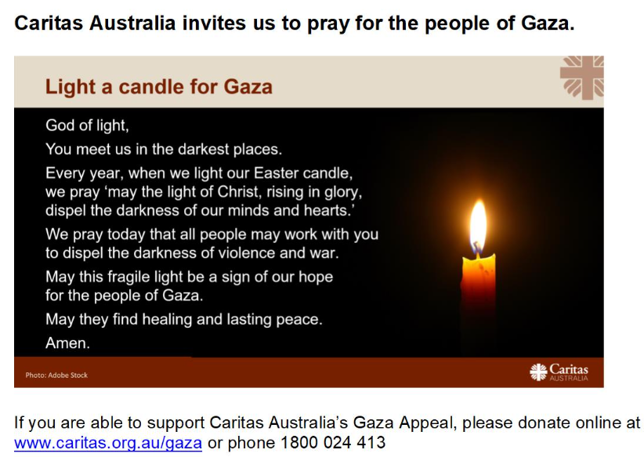

**PARISH PRIEST**

Father Mark Croker

0428 190 759

**02 6452 2062**

**PRIEST**

**Sacramental Program**

Father Mark Croker

0428 190 759

**PARISH WEBSITE**

www.cg.org.au/cooma

**Parish Secretary**

Mrs Sharon Nesbitt

02 6452 2062

Mon, Wed & Thu

9am -1pm & 2pm - 4.30pm

Email: cooma@cg.org.au

**ST PATRICKS SCHOOL**

02 6452 1721

**School Principal**

Dr Mangan

School Website: [www.stpatscooma.nsw.edu.au](http://www.stpatscooma.nsw.edu.au)

**PARISH PASTORAL COUNCIL**

Darren 0429 904 291

**WEEKEND MASS**

**& LW&HC TIMES**

**Adaminaby**

No Mass until further notice

**Berridale**

2nd & 4th Sunday

Vigil Mass Saturday 3.30pm

All other Sundays

LW&HC 10am Sunday

**Cooma**

Mass Sunday 10am

Mass Tue, Thu & Fri 10am

***Except 3rd Friday***

Mass Yallambee Lodge 9.30am

Mass Hudson House Respect 11am

**Jindabyne**

1st 2nd 3rd & 4th Sunday

Vigil Mass Saturday 5pm

All other Sundays

LW&HC 5pm Saturday

**Nimmitabel**

5th Sunday

Vigil Mass Saturday 5pm

All other Sundays

LW&HC 5pm Saturday

**Numeralla**

2nd Sunday LW&HC 5pm

4th Sunday Mass 5pm

**PARISH CONTACTS**

**PRAYER INTENTIONS**

**PARISH CALENDAR**

p

**Recently Deceased**

Joan Cahill wife of Neville mother to Maria & Debbie - funeral Mon 11am St Andrews Nimmitabel;

George Karooz father of Jo-Anne, Dianna, Angela, Peter and John. Funeral Mass 1pm Fri 5th September;

Brian Standen; Barbara Schofield;

James Sullivan, Adela Roach,

Bill Fasch, Elaine Mooney

Don McDonald, Celia Dalby

**Anniversaries & Intentions**

Margaret Hassall, Terry Green,

Bill Smith, Shirley Caldwell



“We have loved them in Life:

Let us not forget them in death.”

St Vincent de Paul local Monaro Conference will be holding the Winter Appeal collection on the 14th Sept 2025.

Donations will be greatly accepted at the Church doors after Mass, envelopes are available for your valued support and can also be returned via collections for delivery.

**Clergy Retirement Foundation**

**Father’s Day Appeal**

**Weekend 6th 7th Sep**

**The annual collection for our retired priests: there are 24 of our Archdiocese who after years of faithful and generous service now come under the care of the Clergy Retirement Foundation. The annual Father’s Day Appeal raises much needed funds to meet the needs of these priests and to give them security in their retirement years. At next weekend’s Masses, you will have the opportunity to donate to this Appeal. All gifts are tax deductible. Please give generously as you have in the past. Donations can also be made at www.cgcatholic.org.au/donate**

**REMEMBERING**

**THEIR FAITH AND LOVE**

**MONARO MEN’s BREAKFAST**

**Date:**          6-Sep-2025 Saturday  
**Time:**          7:30 am  
**Speaker**:       Kevin Dunne -- Retired Principle

from St Patricks School  
**Venue:**         Church Hall (St Paul's Anglican),

136 Commissioner St  
**Cost $**:        $ 7.00  
**Invitation to**: Men Only

Please see flyer in Church entrance for more information

**Priest: Encouraged by the compassion of Christ towards those in pain, we turn to God in our need.**

**Leader:**

**For all who exercise authority in the church: that they may follow in the footsteps of Christ and inspire all those who are struggling in their spiritual journey. Lord, hear us.**

**For all who exercise authority in the world, and especially in our own country: that they may reach out to those who are most in need.**

**Lord, hear us.**

**For the gift of peace: that God will guide and affirm all who are working to end war, terrorism, and violence in so many war-ravaged countries. Lord, hear us.**

**For all those suffering because of natural disasters, especially the devastating bushfires throughout Europe at the present time: that they may be comforted in their grief and loss and supported as they face the future. (pause) Lord, hear us.**

**For all who have died, we pray for George Karooz and Joan Cahill that in the fullness of eternal life they may share the rewards of their humble service of God and neighbour**

**Lord hear us.**

**Let us pray with Mary for our own intentions: Hail Mary….**

**PRIEST: God of all consolation, you gather your people to teach them your ways and to remind them of your mighty deeds. With confidence, we ask you to hear our prayers, through Christ our Lord. Amen.**

**Prayer of the Faithful**

***Response:*** ***(R)***

***Lord, hear our prayer***

**Part Time Parish Secretary – Positions Vacant – Parish Officer**

**Essential Requirements for Parish Officer roles in the Parishes of: -**

***- Tumut, Gundagai, Adelong & Batlow;***

***- South Tuggeranong and Bungendore:***

***- Cooma Parish***

**- Bungendore Parish**.

This is a part-time permanent position for hours per week.

Essential Requirements:

* Employment conditions are subject to Clerks Award. For a copy of the Duty Statement please email the Parish Office Experience with database packages & Microsoft Suite
* Strong communication and liaison skills
* Strong organisational skills
* Ability to work on your own, as part of a team, and take direction
* Understand and administer areas of church and regulatory compliance (eg. Parish sacrament registers, Working With Vulnerable People, WHS, child protection, copyright)
* Understanding and respect for the Catholic Church and its teaching
* Current experience in an office environment. A PD is avail.

z

50th Wedding Anniversary Blessings

Congratulations to Geoff and Therese Ferguson

on the celebration of their 50th Anniversary of Marriage

this weekend in Numeralla All Saints Catholic Church

**ROSTER**

|  |  |  |
| --- | --- | --- |
|  | **31st Aug** | **7th Sep** |
| **Acolyte** | Kaitlyn Bosco | Richard Cmunt |
| **Usher** | Pauline Radosavljevic | Mary Bennett |
| **Reader/**  **Commentator** | Bosco family | Jo-Anne Brown Lou Mackay |
| **Mass Servers** |  | |
| **Special Minister** | Mike Introna | Heather Collin |
| **Children’s Liturgy** | Carol Byrne | Suja Tessy |
| **Linen** | Michele Atkins | Gaie Mooney |
| **Church Care** | 6th S McPhie  L Baker B Moser | 13th Bilish family |
| **Hospital** | Leah Baker | Kathleen Bashford |
| **Flowers** | Claire Nuemeyer | |

St Patrick’s Parishioners **are invited to attend Fathers Day Event 5th September 3.45pm -5.30pm**

**Please Contact Sarah Hamilton or Jolanta Zieja at the School Reception please phone 64521721**



**Twenty-Third Sunday In Ordinary Time/Year C**

**First: Wisdom 9:13-18**

**Second: Phlm 9-10,12-17**

**Gospel: Luke 14:25-33**

**READINGS FOR NEXT WEEKEND**