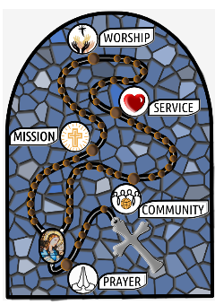
Future of the Parish: meeting with Vicar-General and Chancellor of the Archdiocese
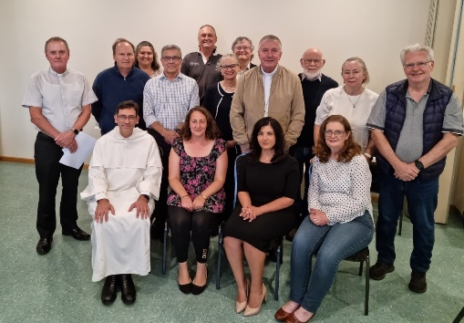
Following the announcement last December of the departure of the Dominicans from the parish at the end of November this year, Fr Mannes and the parish renewal team have been in contact with Fr Richard Thompson, Vicar-General, and Dr Patrick McArdle, Chancellor of the Archdiocese (correspondence available on the parish website). On 9 March, a meeting was held in the parish centre to begin discussion on the future of the parish. Archbishop Christopher was able to attend briefly at the start to encourage a focus on Jesus, prayer, spirituality and mission.
The Archdiocese’s planning is a work in progress, but Fr Richard and Patrick emphasised that there was no intention that Holy Rosary church be closed or left without the services of a priest. The strong intention is that Sunday Masses would continue to be celebrated at the church.
The Archdiocese is in discussion with a congregation of priests about new arrangements for Holy Rosary church and Blackfriars Parish as part of a broader consideration of the nature of ministry in, and the shape of, a number of parishes in Canberra’s inner north. This will be done in consultation with these parishes (Watson, Dickson, Braddon, Campbell, O’Connor). The process of discerning new arrangements will take time and might occur in stages, with an interim arrangement at the end of 2023 and more permanent arrangements developed in the longer term, including possible parish mergers. The process would emphasise opportunities to share and grow together in faith.
Fr Richard and Patrick hope to have further information for the parish meeting on 30 March following meetings of the diocesan Council of Priests and College of Consultors.
As Fr Mannes has indicated (see his notice in recent bulletins), the 30 March meeting will also address current Mass times. It will be an opportunity to hear about, and ask questions and provide your views on, parish renewal (some information on renewal initiatives to date is set out separately in this bulletin) and the future of the parish. Please consider attending.
Parish renewal team
Members of the parish renewal team: Sabina Coles, Melanie Cox, Emily Hall, Keith Linard, Peter McDonald, Roger Paul, Siobhan and Richard Tanzer, Fr Mannes Tellis, Kate Watson, Nicole Webb and Helena Zobec.

Parish renewal: 2019 to now
In 2018 and early 2019 there were a number of Archdiocesan and Parish meetings inviting Catholics to express their priorities for synod of the Australian Church. About fifty Holy Rosary parishioners in total took part in this process and a submission was made as part of the Plenary Council process. The last such meeting at Holy Rosary suggested that our parish needn’t wait for the Plenary Council to meet and make decisions, but that we should commit ourselves immediately to renewal. So, at all Masses on the weekend of 24 March 2019, parishioners were invited to attend a meeting to discuss the next steps in our parish renewal. The Parish Notice concluded: “Every parishioner is welcome to attend the meeting and to become involved in the parish renewal now and as it unfolds, Your views are vital. The success of the renewal depends on your input and participation.”
The suggestions at the well-attended meeting of 27 March 2019 were forthright and wide-ranging, filling two whiteboards. A group of six parishioners were delegated by the meeting to pull together the threads from these deliberations to suggest a way forward. This led to inviting parishioners to participate in a series of six sessions to deliberate prayerfully on the acclaimed parish renewal book Divine Renovation – From a Maintenance to a Missional Parish by Fr James Mallon. Between seventeen and twenty-five parishioners participated in these sessions over October and November 2019. At the final session it was proposed that the next step in parish renewal should be to run the ALPHA program. Over the three and a half years since then, despite the COVID-19 lockdown and restrictions (and with the help of ZOOM), the renewal program has continued and broadened including: four adult and one youth ALPHAs, weekly Eucharistic Adoration, Laudato Si’ dialogue (based on Pope Francis’s Encyclical letter, Laudato Si’ – On Care for Our Common Home), Women’s Faith Circle, Walk in the Spirit and subsequent Lenten Programs, Advent Program (developed by members of the renewal team in collaboration with the Archdiocese) and a variety of ecumenical initiatives with the local Anglican, Uniting, Baptist and Church of Christ communities including the joint North Canberra Nativity Festival each year, a Week of Prayer for Christian Unity, six weeks of parish prayer for parish renewal, and now joint planning for the Rosary 60th Anniversary and the Holy Cross 60th Anniversary. Following each activity, new people have volunteered to be part of the renewal team, whilst some have dropped off.
Not counting those involved in traditional parish activities (monthly luncheons, Dominican laity, St Vincent de Paul, Parish School of Religion, weekly Reader Formation, Bible Study, Meditation Group, Craft Group, Pray the Rosary etc), the total number of people who have participated in the activities sponsored or supported by the parish renewal team is roughly 215. Taking into account multiple attendances, some 100 individuals (or 25% of Sunday Mass goers) have participated in these activities. If we add in the number of individual parishioners (including children at Rosary School) who attended the North Canberra Nativity Festival these past 3 years, the number goes up to 200+ individuals ... more than 50% of Sunday Mass goers.
The renewal team is not a Parish Pastoral Council, but a (flexible) group of parishioners who have volunteered to work with Fr Mannes and with existing parish groups and Ecclesial Movements to promote Gospel based renewal. In the absence of a Parish Pastoral Council, the renewal team has taken the initiative in seeking wider parish involvement in input to the proposed Diocesan Pastoral Council and in discussions following the decision that the Dominican Fathers will cease their apostolate in Canberra in November 2023.

