Laudato Si’ celebration
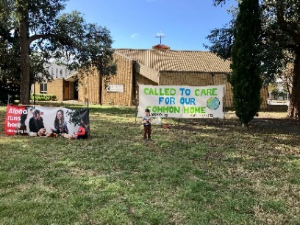
You may have seen the Called to Care for Our Common Home banner at the front of Holy Rosary Church. It’s part of our parish’s contribution to the Laudato Si’ celebration being held in the Archdiocese at the moment. This note explains some of the other Laudato Si’ inspired initiatives at global, archdiocesan and local levels.
Laudato Si’ (‘Praise be to you’) – On Care for our Common Home is a 2015 encyclical by Pope Francis, which he addressed to ‘every person living on this planet’, saying that he’d like to ‘enter into dialogue with all people about our common home’ (LS, 3). Laudato Si’ provides a comprehensive approach to God’s creation and the place of humankind in his plan.
The seven year anniversary of Laudato Si’ was marked by Archbishop Christopher at last Sunday’s (22 May) 11am Mass at St Christopher’s Cathedral : see https://www.catholicvoice.org.au/a-holistic-approach-to-political-social-economic-and-environmental-problems/. Joining him were Aboriginal leaders and Presbyterian pastor Rev David Campbell, president of the ACT Churches Council. In his homily, Archbishop Christopher referred to the encyclical’s focus on integral ecology that ‘embraces everything, not simply the environment’, evoking Pope Francis’s statement in Laudato Si’ that St Francis of Assisi ‘shows us how inseparable is the bond between concern for nature, justice for the poor, commitment to society, and interior peace’ (LS, 10).
Our Archdiocese has started to develop and to encourage plans of action on Care for Our Common Home by way of response to the Laudato Si’ Action Platform, a ‘unique collaboration between the Vatican, an international coalition of Catholic organizations, and “all men and women of good will” … empowering all to take “decisive action, here and now” [LS, 161] as we journey towards a future together’: https://laudatosiactionplatform.org/about/. The most recent social justice statement of the Australian Bishops – Cry of the Earth, Cry of the Poor – encourages parishes, families, dioceses, schools and businesses to join this Action Platform journey.
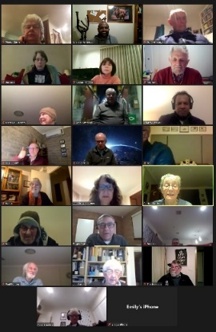
This weekend, a short video of Pope Francis encouraging involvement in the Laudato Si’ Action Platform will be shown at Masses: https://www.catholicvoice.org.au/pope-francis-invites-action-on-care-for-our-common-home/. To get a transcript, please contact the Parish Office.
To further the dialogue that Pope Francis encourages, Blackfriars Parish organised a Laudato Si’ dialogue last year: see photo. We welcomed participants from not only Blackfriars but also Holy Cross, St Margaret’s, St Brigid’s and other places.
Another dialogue is being organised, starting on 14 June, this time by the Archdiocesan Caring for Creation Movement (of which a Blackfriars parishioner, Roger Paul, is a member). A number of expert speakers have agreed to share their thoughts on various topics relating to the encyclical, eg on the science and impacts of climate change, the economic pespective of Laudato Si’, and faith and science. The dialogue will be an opportunity for participants to share their experiences and their ideas for taking forward Pope Francis’s message. Registration details over the page.
Coincident with the current celebrations was Fr Mannes’s announcement last weekend that Blackfriars Parish will be installing solar panels (see also the 2022 parish finance update). Laudato Si’, in this regard, calls for approaches to reducing carbon dioxide emissions by, for example, replacing fossil fuel energy with sources of renewable energy (LS, 26).

On Care for Our Common Home

What: a dialogue on caring for God’s creation, based on Pope Francis’s encyclical, Laudato Si’ (‘Praise be to you’) – On Care for Our Common Home.
Who: everyone interested in a respectful and wide-ranging discussion in a Christian context.
When: fortnightly, 7.30 – 9pm, starting 14 June 2022 and ending 4 October 2021.
Where: Online – Zoom details provided to participants.
Cost: no charge.
Papal encyclical: Laudato Si’ is available at https://www.vatican.va/content/francesco/en/encyclicals/documents/papa-francesco_20150524_enciclica-laudato-si.html. Hard copies can be purchased (check Canberra Catholic Bookshop, 55 Franklin St, Forrest; ph 6239 9888).
Registration: Registration through TryBooking: https://www.trybooking.com/BZMCP. This QR Code will also take you to the booking page.
Numbers: Numbers limited. A waiting list will apply if interest exceeds the limit. If unable to participate in this dialogue but are interested in future participation, please email your expression of interest to laudatosiACT@gmail.com.
Further information: at https://www.care4creation.org/home/, contact Roger Paul on 0421 612 572 or email laudatosiACT@gmail.com.

