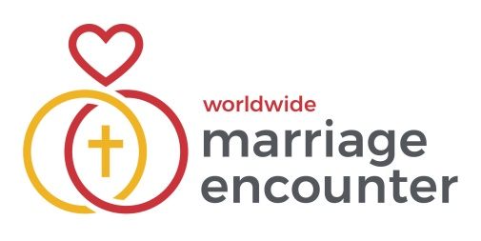

Dear Brothers and Sisters in Christ,

Worldwide Marriage Encounter has 2 Weekends scheduled for 2025– the first Weekend is in May!!  We would greatly appreciate a mention from now until this event, in your parish/school/community bulletin/newsletter (see below). Please edit to fit your available space, if necessary. Also, please pray for the Marriage Encounter Team as we make preparations for this Weekend.

**NOTICE SUGGESTION**

**Marriage Enrichment Weekend**

*We are offering an opportunity for you to learn to become the best version of yourselves together and live your best life in love!*

**Come and join us on 23-25 May 2025 at a Marriage Encounter Weekend at Mt Carmel Retreat Centre, Varroville, NSW – a stunning & tranquil oasis on the edge of Sydney.**

**Book online at** [www.wwme.org.au](http://www.wwme.org.au/)  or contact**Christine & Terry Mahony on 0490 774 419 or** nswbookings@wwme.org.au

If you would like more information about Worldwide Marriage Encounter please see the WWME website at [www.wwme.org.au](http://www.wwme.org.au)

Thank you for your support of the Worldwide Marriage Encounter movement.

In the love of Our Lord, our sincere thanks,

Fr Terry Herbert, Tracey and Richard Kaldasaun

Unit Coordinators and Ecclesial team

Worldwide Marriage Encounter Australia – Eastern Unit

[www.wwme.org.au](http://www.wwme.org.au)