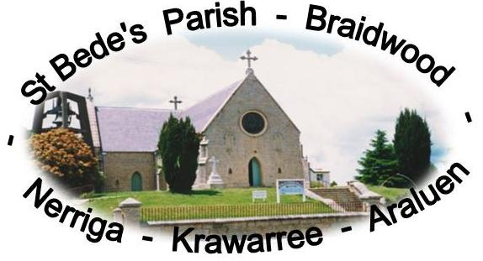

4TH SUNDAY OF ADVENT YEAR B
20 December 2020
Liturgy and Bulletin

2ND SUNDAY OF ADVENT YEAR B
6 December 2020
Liturgy
and Bulletin

1ST SUNDAY OF ADVENT YEAR B
29 November 2020
Liturgy and Bulletin

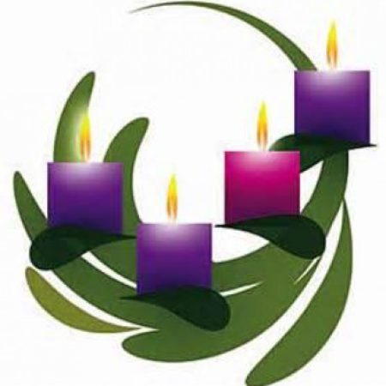

OPENING PRAYER
Lord,
Fill our hearts with your love,
and as you revealed to us by an angel
the coming of your Son
so lead us through his suffering and death
to the glory of his resurrection,
for he lives and reigns with you for ever and ever
Amen.

FIRST READING: A reading from the second book of Samuel

Once David had settled into his house and the Lord had given him rest from all the enemies surrounding him, the king said to the prophet Nathan, ‘Look, I am living in a house of cedar while the ark of God dwells in a tent’. Nathan said to the king, ‘Go and do all that is in your mind, for the Lord is with you.’
But that very night the word of the Lord came to Nathan:
‘Go and tell my servant David, “Thus the Lord speaks: Are you the man to build me a house to dwell in? I took you from the pasture, from following the sheep, to be leader of my people Israel; I have been with you on all your expeditions; I have cut off all your enemies before you. I will give you fame as great as the fame of the greatest on earth. I will provide a place for my people Israel; I will plant them there and they shall dwell in that place and never be disturbed again; nor shall the wicked continue to oppress them as they did, in the days when I appointed judges over my people Israel; I will give them rest from all their enemies. The Lord will make you great; the Lord will make you a House. And when your days are ended and you are laid to rest with your ancestors, I will preserve the offspring of your body after you and make his sovereignty secure. I will be a father to him and he a son to me. Your House and your sovereignty will always stand secure before me and your throne be established for ever."'

RESPONSORIAL PSALM:
Response: For ever I will sing the goodness of the Lord.

1. I will sing for ever of your love, O Lord;
through all ages my mouth will proclaim your truth.
Of this I am sure, that your love lasts for ever,
that your truth is firmly established as the heavens. (R.)

2. ‘I have made a covenant with my chosen one;
I have sworn to David my servant:
I will establish your dynasty for ever
and set up your throne through all ages.’ (R.)

3. He will say to me: ‘You are my father,
my God, the rock who saves me.’
I will keep my love for him always;
for him my covenant shall endure. (R.)

SECOND READING: A reading from the letter of St Paul to the Romans

Glory to him who is able to give you the strength to live according to the Good News I preach, and in which I proclaim Jesus Christ, the revelation of a mystery kept secret for endless ages, but now so clear that it must be broadcast to pagans everywhere to bring them to the obedience of faith. This is only what scripture has predicted, and it is all part of the way the eternal God wants things to be. He alone is wisdom; give glory therefore to him through Jesus Christ for ever and ever. Amen.

Gospel Acclamation
Alleluia, alleluia!
I am the servant of the Lord:
may his will for me be done.
Alleluia!

GOSPEL: A reading from the holy Gospel according to Luke

The angel Gabriel was sent by God to a town in Galilee called Nazareth, to a virgin betrothed to a man named Joseph, of the House of David; and the virgin’s name was Mary. He went in and said to her, ‘Rejoice, so highly favoured! The Lord is with you.’ She was deeply disturbed by these words and asked herself what this greeting could mean, but the angel said to her, ‘Mary, do not be afraid; you have won God’s favour. Listen! You are to conceive and bear a son, and you must name him Jesus. He will be great and will be called Son of the Most High. The Lord God will give him the throne of his ancestor David; he will rule over the House of Jacob for ever and his reign will have no end.’ Mary said to the angel, ‘But how can this come about, since I am a virgin?’ ‘The Holy Spirit will come upon you’ the angel answered ‘and the power of the Most High will cover you with its shadow. And so the child will be holy and will be called Son of God. Know this too: your kinswoman Elizabeth has, in her old age, herself conceived a son, and she whom people called barren is now in her sixth month, for nothing is impossible to God.’ ‘I am the handmaid of the Lord,’ said Mary ‘let what you have said be done to me.’ And the angel left her.

Reflection on the Gospel by Richard Leonard
On this final Sunday of Advent the Church moves our gaze to the Annunciation. The whole scene hinges around one word: ‘Yes.’ Mary's fiat sets in motion the entire Christian drama. In his film Jesus of Nazareth Franco Zeffirelli pictures the Annunciation this way: Mary is asleep at night when a gust of wind opens a high window. Afraid at all the commotion Mary gets up and starts to pray. As she prays, we see her face change and her body bend over. With tears in her eyes, Mary looks up through the window to the moonlit sky and simply says, ‘Yes’. The swirling wind dies down at once.

In recent years successive popes have reminded us that the best devotion to Mary is one that leads us to do what she did: say ‘yes’ to Jesus. Mary is not a stop on our journey of faith; she is a guidepost that always sends us on to Christ. Mary does not save us, for we believe she needed to be saved by Christ as well. That's why she could say yes in the first place. Mary recognised the gift and the giver and became the bearer of God for the world.
PRAYER OF THE FAITHFUL

Reader: May our Australian government show respect and justice for refugees in our detention centres, especially the family on Christmas Island.
(pause) In your glory:
All: Lord, hear our prayer.

Reader: That, like the Virgin Mary, we may have the grace of certain trust in the Lord. (pause) In your glory:
All: Lord, hear our prayer.

Reader: That conflict and war will be silenced so people of all nations may live securely in God. (pause) In your glory:
All: Lord, hear our prayer.

Reader: That our parish community will honour Mary as the most blessed Mother of Christ. (pause) In your glory:
All: Lord, hear our prayer.

Reader: That the sick who call upon your name may be given life and healing, especially
Tony Riley, Don Raper, Rupert Ermert, Ann McDougall, Val Biggers, Celia Roach, and Mark Sissian. (pause) In your glory:
All: Lord, hear our prayer.

Reader: That those who have died may share in the eternal life fulfilled by Christ Jesus, including
Tom Richardson, Frank Stephens and our own deceased relatives and friends.
(pause) In your glory:
All: Lord, hear our prayer.

CONCLUDING PRAYER
Lord,
As we receive the promise of salvation
make us grow in faith and love
to celebrate the coming of Christ our Saviour.
Amen.
____________________________________________________________________________________
Hello St Bede’s Parishioners,
Mass last Saturday evening was attended by 50 parishioners. Social distancing, hygiene requirements and recording attendance procedures are still being observed. Please try to arrive in good time as all these regulations and requirements will take time. The protocols are being slowly relaxed, singing is now allowed and distancing is now 2 square metres inside the church.
Weekday Masses: Tuesday 22 December only at 10am
Meditation: Thursdays at 10.30am in the Presbytery.
Adoration: in recess until end of January 2021
Social Justice Group: meets in the Church Sunday 7th February 2021 at 10.30am.
Christmas Masses: 24 December: 5pm Family Mass; 7pm Night Mass. Bookings will be either online at https://www.trybooking.com/BMYAJ or phone/text Helen on 0430169849. Bookings for Family Mass will be in Families; 7pm to be booked as individuals. Bookings open 1 December and close 23 December. Please let any family coming home for Christmas know that they (or you) must book to be sure of a place at their Mass of choice. We might not like them but the restrictions are there to keep us safe.
Nine Lessons and Carols at ST Andrew’s Anglican Church this Sunday 20 December, at 7.00pm
Araluen Stations of the Cross: 3.00pm First Friday of every month, commencing 4 December. All welcome.

Reconciliation this year will take place within Mass on Saturday night 19 December – as an extended penitential Rite. Please come along if you can.

Church cleaning: Wednesday 23rd Dec at 9am. Please come and help smarten up our church for Xmas
Christmas Flowers: please bring to church on Thurs 24 Dec at 9.30 am. All decorators please if you can

Brother Brian will be taking his annual leave from January 10 to February 5.

No liturgies or bulletins during January, unless something important crops up. I, too, will be having a break of sorts during January. Helen

Return Thanks: Bob’s family offers their sincere thanks for your kind expressions of sympathy and your thoughtful gestures. It was greatly appreciated and will always be remembered.
Regards Norah, Tony & Fay, Kate and Don and their families.

The Archbishop’s Christmas Appeal for 2020 is conducted at all Christmas Masses throughout the Archdiocese and will again have the funds raised split.
- Our support will continue for the ecumenical Christmas Bowl appeal and its work in Australia, Africa, Asia and Oceania.
- Contributions will be made to support Diocesan projects locally, within Wilcannia Forbes Diocese and globally, within the Dioceses of Otukpo, Nigeria, Thamarassery, India and Gizo Diocese PNG. Within Gizo Diocese assistance will support construction of a multipurpose hall at a school for migrant children from Kiribati and Malaita in Nusabaruku.
- Other international endeavours will include support towards:
projects focused on helping the poor within the La Salette Matha Province and by the Society of the Oblates of the Sacred Heart (OSH) in India; and further student assistance for those in need at Bethlehem University in the Holy Land.

We will once again use our collection bags for the Christmas Masses. If our collectors could speak to Br Brian re procedure before the Masses, it would be much appreciated. We will need 2 collectors for each Mass (3 if the gallery is occupied)

Next week’s Readings:
Christmas: 1st: Isaiah 9:1-7. 2nd: Titus 2:11-14. Gospel: Luke 2:1-14.
Holy Family: 1st Gen. 15:1-6,21:1-3. 2nd: Hebrews 11:8,11-12,17-19. Gospel: Luke 2:22-40.

Offerings received last week acknowledged with thanks:
1st: . Planned Giving envelopes: $70.35. Loose: $100. Please note that it was decided at the PPC meeting that all moneys, including the Planned Giving envelopes, tap and online donations, would be divided between the 1st and 2nd collections, with 30% of the total being given to the 1st collection (for clergy and the running of the Archdiocese.)
If you would like to consider Direct Debit through the Catholic Development Fund, please ask for the forms.

Ministry Rosters for Restrictive Masses
Date Acolyte Welcomer Readers PowerPoint
19 Dec James Cathy F …………/Ann Helen H
24 Dec 5pm Felix Cathy F Wendy H/Germaine Helen H
24 Dec 7pm James Geraldine Rod/Miah Geoff Pollard
26 Dec Geoff Helen P Helen B/Germaine Helen H
2 Jan Felix Cathy F Wendy M-B/Ann Helen H
9 Jan James Geraldine Wendy H/Germaine Helen H
16 Jan Geoff Helen P Rod/Bobbie Helen H
23 Jan Felix Cathy F Helen B/Michael Helen H
30 Jan James Geraldine Wendy M-B/Ann Helen H
Please let me know as soon as possible if you won’t be attending, especially the Christmas Masses so other arrangements can be made.

COVID-19 Links for information: https://www.nsw.gov.au/covid-19
Mass Online Link: https://catholicvoice.org.au/mass-online
Masks are not mandatory but recommended. Please feel free to wear one to Mass if you wish.

Look after each other,
Helen Hart

