Immaculate Conception Parish

P O BOX 600 Tumut
Catholic Community
Collection amounts for January 2016 ~PARISH NEWS~
~ PARISH NEWS ~
~ GOSPEL REFLECTION ~

It is easy enough to be taken in by the posturing of those who present as superior and who look for status recognition. It is also easy to miss the goodness of those on the edge even if it is happening before our very eyes. The context presents Jesus as attuned to the plight of the widows. He now notices and draws the attention of his disciples to the action of one particular “destitute” widow. Her tiny contribution to the treasury of two copper coins for the upkeep of the Temple is far more significant than the big sums contributed by the wealthy out of their excess. Is this woman being presented as the victim of an unjust system that extracts from her what she cannot afford, as some commentators insist? Or is the Markan Jesus presenting her as a free agent, a model of discipleship, who offers everything she has to live on? It may not be necessary to choose between these two interpretations. It is clear that this woman’s action provides a striking contrast to that of the scribes, like the action of another woman who, a little later in the story, breaks a precious jar and pours an abundance of healing ointment over the head of Jesus as he faces the prospect of death. As the gospel draws to a close, then, we find two stories of extravagantly generous unnamed women, stories told in memory of their gospel foolishness.. An excerpt by Sr. Veronica Lawson

PLENARY COUNCIL PRAYER Come, Holy Spirit of Pentecost. Come, Holy Spirit of the great South Land. O God, bless and unite all your people in Australia and guide us on the pilgrim way of the Plenary Council. Give us the grace to see your face in one another and to recognise Jesus, our companion on the road. Give us the courage to tell our stories and to speak boldly of your truth. Give us ears to listen humbly to each other and a discerning heart to hear what you are saying. Lead your Church into a hope-filled future, that we may live the joy of the Gospel. Through Jesus Christ our Lord, bread for the journey from age to age. Amen. Our Lady Help of Christians, pray for us. Saint Mary MacKillop, pray for us.

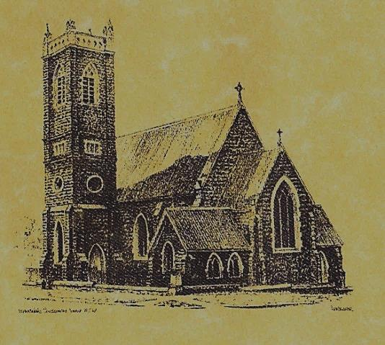

‘CLERGY’
Fr. George Ogah (Administrator) Fr. Namora Anderson (Assisting Priest)

‘PARISH SECRETARY’
Anna Quinn
Phone: 02 69474599
Email: tumut@cg.org.au
Web: www.cg.org.au/tumut
Office hours: Wednesday & Friday 9am -12noon
--------------------------------------------------------
‘WEEKEND MASS TIMES’
Saturday Vigil: 6pm
Sunday: 10am
Talbingo: 9am Communion Liturgy 1st & 3rd 8am Mass 2nd & 4th

‘ROSARY’ Saturday: 8.45am
Exposition 8.30am (1st Sat of month)

‘RECONCILIATION’
Saturday at 5.15pm

‘LITURGY MEETING’
Tuesday: 2.00pm in Chapel

‘PRAYER GROUP’
(Rosary & Divine Mercy)
Wednesday: 2.00pm in Chapel

‘CONTACTS’
Care Group: Anne Huebner 69473406

32nd Sunday in Ordinary Time Year B November 11th 2018
November 4th 2018

Gospel Acclamation
Alleluia, alleluia! Happy the poor in spirit; the kingdom of heaven is theirs! Alleluia!

Responsorial Psalm
Praise the Lord, my soul!
Entrance Antiphon
Let my prayer come into your presence. Incline your ear to my cry for help, O Lord.
Gospel Acclamation
-----------------------------------
Alleluia, alleluia! Tomorrow the wickedness of the earth will be destroyed; the Saviour of the world will be our king. Alleluia!

T THIS WEEK Saturday & Sunday 10th & 11th November

Ministry | Saturday Vigil 6pm | Sunday 10am
Acolyte | Trish Matthews | Sue Bulger
Reader | Patricia Wilks | Kirsty Beavan
Commentator | Maureen Cook | Mary Kelly
Children’s Liturgy | ---------- | Caitlin Larter
Musicians | Anna Quinn | Patricia & Monica
Altar Servers | Xavier Henderson & Riley Hotham | Jessica & Emily Kelly
Church Care  ________________________  LINEN Marie Ambrose | Group 1: Claire, Anne Hickson, Bev & Sophie
NEXT WEEK Saturday & Sunday 17th & 18th November
Ministry | Vigil 6pm |  | 10am
Acolyte | Tony Butler |  | Mark Hogan
Reader | Anne Huebner |  | Mary Kelly
Commentator | Lana Turner |  | Cathy Purcell
Children’s Liturgy | ---------- |  | Pat Spannagle
Musicians | Patricia & Monica |  | Anna Quinn
Altar Servers | Jude Moreno & TBC |  | Abby Crampton & Olivia Dean
Church Care | ----------------------------------------
Feast DayWishing all ouFEASTS DAYS
R O S T E R S
Feast Days 12th Nov: Saint Josaphat 17th Nov: Saint Elizabeth of Hungary
Injustice anywhere is a threat to justice everywhere. We are caught in an inescapable network of mutuality, tied in a single garment of destiny. Whatever affects one directly affects all indirectly. Martin Luther King Jr.
~PARISH NEWS~
WEEK DAY MASSES Fr. George will be attending a retreat from Monday 12th to Friday the 16th November, there will be no Masses next week. For any emergencies please contact Anna on 0419472568. Saturday morning Mass will resume on 23rd November when Fr. Namora returns from leave. BAPTISMS we welcome into our community Zoe Isabella Carter daughter of Steven and Amanda and Audrey Eileen Carmody daughter of Jonathon and Samantha. We pray for all baptism families. CATHOLIC VOICE take and read the November edition. MASS REQUEST yellow envelopes are on table at back of church for your ‘Holy Souls’ November Mass intentions. LOW GLUTEN HOSTS are available upon request. Please speak to Acolyte or Priest before Mass service. 2019 DAILY MASS BOOKS available to purchase from the presbytery for $22.00 SPECIAL THANKS to Marie Ambrose one of our lovely linen ladies.

We pray for those who have gone before us marked with the sign of faith especially:
RECENTLY DECEASED - BRIAN BALLARD
MASS HAS BEEN REQUESTED FOR:
Marie McInerney, James Kelly, Comai & Marallo families, Joan Malone, Alan & Angela Guthrie, Pearl & Ted Bawden, Natalie Baker, Col Baker, Eric Harris, Tom Sturt, Andrew Sturt, Fr. Peter Quirk, Sr. Dorothy Bray RSM, Jim Lynch, Paul Kelly, Chris Ballard, Van de Brug families, Breward families, Frank, Eileen & Marie Malone, Louis Shallow, John Callister, Maude Kelly, Leo Aarts, Maria Tran, Mick Bristow, Maureen Court, Andrew Sturt., Brian Rosetta, Hassel & Joy McGrath, Noel Cook, Rudi & Filomena Comai, Gus & Kath Clout, Ab & Mildred Shanahan, Ina Clout, Pat Malone, Frank Delany, Ken & Brian Gee, Max Butler, Imelda, Bede & Francis McInerney, John Hourigan, Russell & Peter Ritchie, Peter Bush, Jim McInerney, Kath Stuckey, Iris Stuckey, Minnie Murphy, Alfred & Bridget Claffey, John Marzol, Sean Gordon, Maureen Ashleigh, Edward Mary & Clem Malone, Pat Malone, Reg & Mary Madigan, Matt Downing, Wilkinson & Downing families, Frank Stanfield, Tom & Dorothy French.

