Immaculate Conception Parish

P O BOX 600 Tumut
Catholic Community
Collection amounts for January 2016 ~PARISH NEWS~
~ PARISH NEWS ~
~ GOSPEL REFLECTION ~

The “test” question about divorce that the Pharisees put to Jesus is very strange in a first century Jewish context, as is the reference to women divorcing their husbands. While there is no evidence that anyone in Jewish circles questioned the legality of divorce, there is plenty of evidence for lively debate concerning the grounds on which a Jewish man could divorce his wife: adultery; inferior cooking; even diminished beauty! There were various schools of thought. Jewish law, unlike Roman law, however, did not permit women to initiate divorce proceedings on any grounds at all. From the perspective of the Markan Jesus, Moses only permitted divorce as a concession to “hardness of heart”: it was not so from the beginning. The ideal, he insists, is expressed in the Garden Story of Genesis, the story of “one flesh”, of partnership, of equality and mutuality, of enduring commitment in marriage. The Hebrew word ’ezer which is translated as “helper” in the first reading from Genesis is used in the Psalms of God’s relationship to Israel. It does not denote inferiority of women to men as is sometimes suggested. An excerpt by Sr. Veronica Lawson

PLENARY COUNCIL PRAYER

Come, Holy Spirit of Pentecost. Come, Holy Spirit of the great South Land. O God, bless and unite all your people in Australia and guide us on the pilgrim way of the Plenary Council. Give us the grace to see your face in one another and to recognise Jesus, our companion on the road. Give us the courage to tell our stories and to speak boldly of your truth. Give us ears to listen humbly to each other and a discerning heart to hear what you are saying. Lead your Church into a hope-filled future, that we may live the joy of the Gospel. Through Jesus Christ our Lord, bread for the journey from age to age. Amen. Our Lady Help of Christians, pray for us. Saint Mary MacKillop, pray for us.

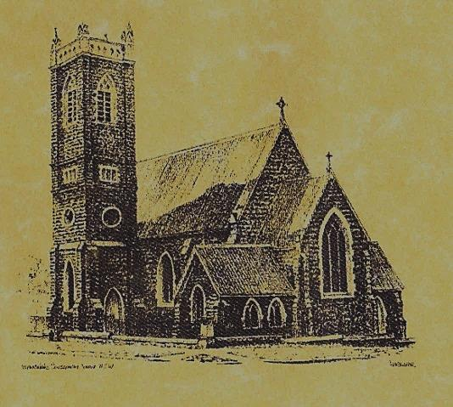

‘CLERGY’
Fr. George Ogah (Administrator) Fr. Namora Anderson (Assisting Priest)

‘PARISH SECRETARY’
Anna Quinn
Phone: 02 69474599
Fax: 02 69474602
Email: tumut@cg.org.au
Web: www.cg.org.au/tumut
Office hours: Wednesday & Friday 9am -12noon
-------------------------------------------------------- ‘WEEKEND MASS TIMES’
Saturday Vigil: 6pm
Sunday: 10am Talbingo 8am

‘THIS WEEKS MASS TIMES’
Tuesday: 6pm in Chapel
Wednesday: 10am
Thursday & Friday: 8am in Chapel
Saturday: 9am
‘ROSARY’ Saturday: 8.45am
Exposition 8.30am (1st Sat of month)
‘RECONCILIATION’
Saturday at 5.15pm
‘LITURGY MEETING’
Tuesday: 2.00pm in Chapel
‘PRAYER GROUP’
(Rosary & Divine Mercy)
Wednesday: 2.00pm in Chapel

‘CONTACTS’
Care Group: Anne Huebner 69473406

27th Sunday in Ordinary Time Year B
October 7th 2018

Responsorial Psalm
May the Lord bless us all the days of our lives.
Entrance Antiphon
Within your will, O Lord, all things are established, and there is none that can resist your will. For you have made all things the heaven and the earth, and all that is held within the circle of heaven; you are the Lord of all.
Gospel Acclamation
Alleluia, alleluia! If we love one another, God will live in us in perfect love. Alleluia!

Gospel Acclamation
-----------------------------------
Alleluia, alleluia! Tomorrow the wickedness of the earth will be destroyed; the Saviour of the world will be our king. Alleluia!

T THIS WEEK Saturday & Sunday 6th & 7th October

Ministry | Saturday Vigil 6pm | Sunday 10am
Acolyte | Tony Butler | Anne Huebner
Reader | Anita Mason | Howard Young
Commentator | Claire Cole | Mary Kelly
Children’s Liturgy | ---------- | ------------
Musicians | Patricia & Monica | Anna Quinn
Altar Servers | Jessica & Emily Kelly | Xavier Henderson & Riley Hotham
Church Care  ________________________  LINEN Maria Cobden | ----------------------------------------
NEXT WEEK Saturday & Sunday 13th & 14th October
Ministry | Vigil 6pm |  | 10am
Acolyte | Anita Mason |  | Sue Bulger
Reader | Carmel Butler |  | Pat Spannagle
Commentator | Maureen Cook |  | Cathy Purcell
Children’s Liturgy | ---------- |  | ----------
Musicians | Anna Quinn |  | Patricia & Monica
Altar Servers | Abby Crampton & Olivia Dean |  | Chloe Turnbull & Lily Webb
Church Care | Group 4: The Dobbie Family
Feast DayWishing all ouFEASTS DAYS
R O S T E R S
COLLECTION AMOUNTS FOR SEPTEMBER 2018 1ST: $1759.10 2ND: $1607.35 D/D: $2080.00
The universe is a communion of subjects, not a collection of objects. ~Thomas Berry~
~PARISH NEWS~
WELCOME BACK to Fr. George who has returned from his leave SATURDAY MORNING MASS & TALBINGO MASS have resumed this weekend. FATHERS DAY APPEAL 2018 sincere thanks to our very generous parishioners who have contributed to this appeal. An amount of $375 has been forwarded from our parish. MARION PROCESSION AND YOUTH PILGRIMAGE 2018 will be held on Sunday 14th October at St. Clement’s Retreat Galong, with the procession to the grotto starting at 2pm. See flyer on notice board for more information. PLENARY COUNCIL 2020: “Listen to what the Spirit is saying” Please return your questionair this weekend to the box in the Church foyer. If you have not completed one, there are spares on the table at the back of the church. Thank you for your efforts. GLUTEN FREE HOSTS are available upon request. Please speak to Acolyte or Priest before Mass service. CATHOLIC VOICE please collect your October issue. MANY THANKS this weekend to our faithful Linen lady ~ Maria Cobden ~

We pray for those who have gone before us marked with the sign of faith:
MASS HAS BEEN REQUESTED FOR:
Natalie Baker, Col Baker, Eric Harris, Andrew Sturt, Fr. Peter Quirk, Sr. Dorothy Bray RSM, Jim Lynch, Paul Kelly, Chris Ballard, Van de Brug families, Breward families, Frank, Eileen & Marie Malone, Louis Shallow, John Callister, Maude Kelly, Leo Aarts, Maria Tran, Mick Bristow, Maureen Court, Andrew Sturt., Brian Rosetta, Hassel & Joy McGrath, Noel Cook, Rudi & Filomena Comai, Gus & Kath Clout, Ab & Mildred Shanahan, Ina Clout, Pat Malone, Joan Malone, Frank Delany, Ken & Brian Gee, Max Butler, Imelda, Bede & Francis McInerney, John Hourigan, Russell & Peter Ritchie, Peter Bush, Alan Guthrie, Jim McInerney, Kath Stuckey, Iris Stuckey, Minnie Murphy, Alfred & Bridget Claffey, John Marzol, Sean Gordon, Maureen Ashleigh, Tom Sturt, Edward Mary & Clem Malone, Pat Malone, Reg & Mary Madigan, Matt Downing, Wilkinson & Downing families, Frank Stanfield, James Kelly, Tom & Dorothy French.

