Immaculate Conception Parish

P O BOX 600 Tumut
Catholic Community
Collection amounts for January 2016 ~PARISH NEWS~
~ PARISH NEWS ~
~ GOSPEL REFLECTION ~

Most of us have to admit to being like the disciples whom Jesus was trying to bring from blindness and ignorance to insight and understanding. Like them, we are often afraid to ask for explanations when we fear that we may not be able to deal with the responses we receive. We so often choose to live in denial. No matter how strongly Jesus insists that the way of the gospel will lead to his violent death, his closest followers persist in their refusal to accept the inevitability of suffering in the life of one who so openly challenges abuses of power.
More focussed on personal recognition and status, the “twelve” engage in a childish argument about who is the greatest among them. They are inside “the house” in Capernaum, the home of Jesus. They are understandably silent when Jesus questions them about the discussion they had “on the way”. They have much to learn and he needs their attention if they are to understand who he is and what it means to be his disciple. They need to learn that being first has nothing to do with seeking the limelight, with hierarchy or status, with power or adulation. It has everything to do with engaging in ministry without distinction or discrimination, with being “servant of all”. Like us, they may also have much to learn from “the way” itself, the path they tread through the land. An excerpt by Sr. Veronica Lawson

PLENARY COUNCIL PRAYER
Come, Holy Spirit of Pentecost. Come, Holy Spirit of the great South Land. O God, bless and unite all your people in Australia and guide us on the pilgrim way of the Plenary Council. Give us the grace to see your face in one another and to recognise Jesus, our companion on the road. Give us the courage to tell our stories and to speak boldly of your truth. Give us ears to listen humbly to each other and a discerning heart to hear what you are saying. Lead your Church into a hope-filled future, that we may live the joy of the Gospel. Through Jesus Christ our Lord, bread for the journey from age to age. Amen. Our Lady Help of Christians, pray for us. Saint Mary MacKillop, pray for us.

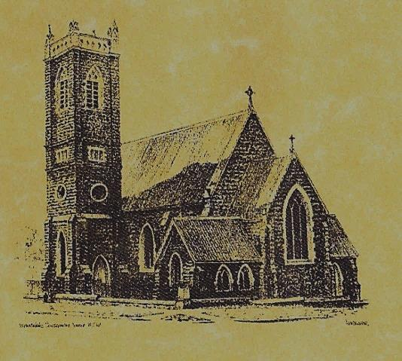

‘CLERGY’
Fr. Michael Mullen (Residing Priest) Fr. George Ogah (Administrator) Fr. Namora Anderson (Assisting Priest)

‘PARISH SECRETARY’
Anna Quinn
Phone: 02 69474599
Fax: 02 69474602
Email: tumut@cg.org.au
Web: www.cg.org.au/tumut
Office hours: Wednesday & Friday 9am -12noon
-------------------------------------------------------- ‘WEEKEND MASS TIMES’
Saturday Vigil: 6.pm
Sunday: 10am

‘THIS WEEKS MASS TIMES’
Tuesday: 6pm in Chapel
Wednesday: 10am (School Mass)
Thursday & Friday: 8am in Chapel

‘RECONCILIATION’
Saturday at 5.15pm

‘LITURGY MEETING’
Tuesday: 2.00pm in Chapel

‘PRAYER GROUP’
(Rosary & Divine Mercy)
Wednesday: 2.00pm in Chapel

‘CONTACTS’
Care Group: Anne Huebner 69473406

25th Sunday in Ordinary Time Year B
September 23rd 2018

Responsorial Psalm
The Lord upholds my life.
Entrance Antiphon
I am the salvation of the people, says the Lord. Should they cry to me in any distress, I will hear them, and I will be their Lord for ever.
Gospel Acclamation
Alleluia, alleluia! God has called us with the gospel to share in the glory of our Lord Jesus Christ. Alleluia!

Gospel Acclamation
-----------------------------------
Alleluia, alleluia! Tomorrow the wickedness of the earth will be destroyed; the Saviour of the world will be our king. Alleluia!

T THIS WEEK Saturday & Sunday 22nd & 23rd September

Ministry | Saturday Vigil 6pm | Sunday 10am
Acolyte | Barry Madigan | Anne Huebner
Reader | School Mass | Howard Young
Commentator | School Mass | Cathy Purcell
Children’s Liturgy | ---------- | Kerrin Henderson
Musicians | Anna & Maureen | Patricia & Monica
Altar Servers | Chloe Turnbull & Lily Webb | Jude Moreno & TBC
Church Care  ________________________  LINEN Bev Piper | ---------------------------------------
NEXT WEEK Saturday & Sunday 29th & 30th September
Ministry | Vigil 6pm |  | 10am
Acolyte | Trish Matthews |  | Mark Hogan
Reader | Dobbie Family |  | Sue Bulger
Commentator | Dobbie Family |  | John Power
Children’s Liturgy | ---------- |  | ----------
Musicians | Patricia & Monica |  | Patricia & Monica
Altar Servers | Abby Crampton & Olivia Dean |  | Gabbi & Maggi Dalisay
Church Care | Group 3: Yvonne, Lee, Mary, Colleen & Kath
Feast DayWishing all ouFEASTS DAYS
R O S T E R S
Feast Days 27th Sept: Saint Vincent de Paul 29th Sept: Saint Michael, Gabriel and Raphael ~ ~ ~ In the end, we will remember not the words of our enemies, but the silence of our friends. Martin Luther King Jr.
~PARISH NEWS~
SATURDAY MORNING MASS will be in recess during the month of September. WELCOME AND THANK YOU we will welcome Fr. Namora and thank Fr. Michael with a morning tea after the 10am Mass this Sunday. Could ladies please bring a plate. FATHERS DAY APPEAL Collection for retired priests: we apologise for the confusion regarding this Appeal, the envelopes have finally arrived, please make your kind contribution at this weekends Masses. All gifts are tax deductible. ST. VINCENT DE PAUL conference members have regular fortnightly meetings at the Senior Citizens’s room, this month there is one remaining meeting on the 29th September, new members are always welcome. Contact Patricia on 0401472161 for more information. MARION PROCESSION AND YOUTH PILGRIMAGE 2018 will be held on Sunday 14th October at St. Clement’s Retreat Galong, with the procession to the grotto starting at 2pm. See flyer on notice board for more information. PLENARY COUNCIL 2020: “Listen to what the Spirit is saying” This weekend parishioners are invited to reflect on the question “What do you think God is asking of us in Australia at this time?” and complete the Plenary Council Questionaries. Could you return questionaries to the box at the back of the Church by next weekend 29th & 30th September, many thanks for your imput. SPECIAL THANKS to our Catholic group of singers who represented our Parish at Songs of Praise last Sunday evening. We would also like to thank McAuley students and teachers of Stage 5 for presenting the Vigil Mass this weekend.

We pray for those who have gone before us marked with the sign of faith:
MASS HAS BEEN REQUESTED FOR:
Andrew Sturt, Fr. Peter Quirk, Sr. Dorothy Bray RSM, Jim Lynch, Paul Kelly, Chris Ballard, Van de Brug families, Breward families, Frank, Eileen & Marie Malone, Louis Shallow, John Callister, Maude Kelly, Leo Aarts, Maria Tran, Mick Bristow, Maureen Court, Andrew Sturt., Brian Rosetta, Hassel & Joy McGrath, Noel Cook, Rudi & Filomena Comai, Gus & Kath Clout, Ab & Mildred Shanahan, Ina Clout, Pat Malone, Joan Malone, Frank Delany, Ken & Brian Gee, Max Butler, Imelda, Bede & Francis McInerney, John Hourigan, Russell & Peter Ritchie, Peter Bush, Alan Guthrie, Jim McInerney, Kath Stuckey, Iris Stuckey, Minnie Murphy, Alfred & Bridget Claffey, John Marzol, Sean Gordon, Maureen Ashleigh, Tom Sturt, Edward Mary & Clem Malone, Pat Malone, Reg & Mary Madigan, Matt Downing, Wilkinson & Downing families, Frank Stanfield, James Kelly, Tom & Dorothy French.

