Immaculate Conception Parish

P O BOX 600 Tumut
Catholic Community
Collection amounts for January 2016 ~PARISH NEWS~
~ PARISH NEWS ~
~ GOSPEL REFLECTION ~

Today’s gospel reading leads us into a section of Mark’s gospel that explores challenges confronting all disciples on their journey of faith. The first challenge is to clarify the nature of our commitment as disciples of Jesus. If we fail to understand who Jesus is, then we have little chance of understanding the nature of our own call to follow him. Two questions (“Who do people say that I am?” and “Who do you say that I am?”) are addressed to our forbearers in faith communities of the latter part of the first century and to Christians across the millennia. We are invited to hear these questions anew. Do we simply share what “the people” say about Jesus? Are we like Peter who has the right language but only partial insight? Or do we have the wisdom to seek a deeper understanding of the identity of Jesus? An excerpt by Sr. Veronica Lawson

PLENARY COUNCIL PRAYER
Come, Holy Spirit of Pentecost. Come, Holy Spirit of the great South Land. O God, bless and unite all your people in Australia and guide us on the pilgrim way of the Plenary Council. Give us the grace to see your face in one another and to recognise Jesus, our companion on the road. Give us the courage to tell our stories and to speak boldly of your truth. Give us ears to listen humbly to each other and a discerning heart to hear what you are saying. Lead your Church into a hope-filled future, that we may live the joy of the Gospel. Through Jesus Christ our Lord, bread for the journey from age to age. Amen. Our Lady Help of Christians, pray for us. Saint Mary MacKillop, pray for us.

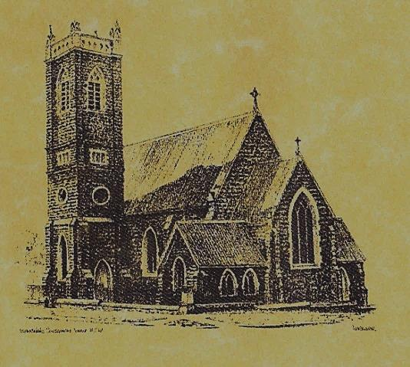

‘CLERGY’
Fr. Michael Mullen (Residing Priest)
Fr. George Ogah (Administrator)

‘PARISH SECRETARY’
Anna Quinn
Phone: 02 69474599
Fax: 02 69474602
Email: tumut@cg.org.au
Web: www.cg.org.au/tumut
Office hours: Wednesday & Friday 9am -12noon
-------------------------------------------------------- ‘WEEKEND MASS TIMES’
Saturday Vigil: 6.pm
Sunday: 10am

‘THIS WEEKS MASS TIMES’
Tuesday: 6pm in Chapel
Wednesday: 10am (School Mass)
Thursday & Friday: 8am in Chapel

‘RECONCILIATION’
Saturday at 5.15pm

‘LITURGY MEETING’
Tuesday: 2.00pm in Chapel

‘PRAYER GROUP’
(Rosary & Divine Mercy)
Wednesday: 2.00pm in Chapel

‘CONTACTS’
Care Group: Anne Huebner 69473406

24th Sunday in Ordinary Time Year B
September 16th 2018

Entrance Antiphon
Give peace, O Lord, to those who wait for you, that your prophets be found true. Hear the prayers of your servant, and of your people Israel.
Responsorial Psalm
I will walk in the presence of the Lord, in the land of the living
Gospel Acclamation
Alleluia, alleluia! My only glory is the cross of our Lord Jesus Christ, which crucifies the world to me and me to the world. Alleluia!

Gospel Acclamation
-----------------------------------
Alleluia, alleluia! Tomorrow the wickedness of the earth will be destroyed; the Saviour of the world will be our king. Alleluia!

T THIS WEEK Saturday & Sunday 15th & 16th September

Ministry | Saturday Vigil 6pm | Sunday 10am
Acolyte | Tony Butler | Dave Shedden
Reader | Liz Bowall | Rodney Little
Commentator | Patricia Wilks | Joanne Little
Children’s Liturgy | ---------- | Pat Spannagle
Musicians | Patricia & Monica | Anna Quinn
Altar Servers
Church Care  ________________________  LINEN Marie Ambrose | Group 2: Anna, Pat, Sophie & Fabiana
NEXT WEEK Saturday & Sunday 22nd & 23rd September
Ministry | Vigil 6pm |  | 10am
Acolyte | Barry Madigan |  | Anne Huebner
Reader | School Mass |  | Howard Young
Commentator | School Mass |  | Cathy Purcell
Children’s Liturgy | ---------- |  | Kerrin Henderson
Musicians | Anna & Maureen |  | Patricia & Monica
Altar Servers | Chloe Turnbull & Lily Webb |  | Jude Moreno & TBC
Church Care | -----------------------------------------
Feast DayWishing all ouFEASTS DAYS
R O S T E R S
Feast Days
19th Sept: Saints Andrew Kim Tae-gon, Paul Chong Ha-sang and Conpanions 21st Sept: Saint Matthew CATHOLIC VOICE September issue is now available, please take your copy
SPECIAL THANKS this weekend to our Sunday Acolyte ~Dave Shedden~
~PARISH NEWS~
SATURDAY MORNING MASS will be in recess during the month of September. WELCOME FR. NAMORA ANDERSON who has been appointed to our parish as Assistant Priest, Fr. Namora will arrived on Friday 21st September, his first Mass in our parish will be next weekend. FATHERS DAY APPEAL Collection for retired priests: we apologise for the confusion regarding this Appeal, the envelopes have finally arrived, please make your kind contribution at this weekends Masses. All gifts are tax deductible. SONGS OF PRAISE will be held at the Seven Day Adventist Church this Sunday the 16th September at 7pm. Supper will be served at conclusion of evening, could those attending please bring a plate to share. ST. VINCENT DE PAUL conference members have regular fortnightly meetings at the Senior Citizens’s room, this month the meetings will be on the 15th and 29th September, new members are always weelcome. Contact Patricia on 0401472161 for more information. MARION PROCESSION AND YOUTH PILGRIMAGE 2018 will be held on Sunday 14th October at St. Clement’s Retreat Galong, with the procession to the grotto starting at 2pm. See flyer on notice board for more information. PLENARY COUNCIL 2020: “Listen to what the Spirit is saying” to prepare the agenda for the Plenary Council, all of the parishioners are invited to reflect on the question: “What do you think God is asking of us in Australia at this time?” Next weekend you will be provided with a Plenary Council Questionarie for you to respond to.

We pray for those who have gone before us marked with the sign of faith:
MASS HAS BEEN REQUESTED FOR:
Sr. Dorothy Bray RSM, Jim Lynch, Paul Kelly, Chris Ballard, Van de Brug families, Breward families, Frank, Eileen & Marie Malone, Louis Shallow, John Callister, Maude Kelly, Leo Aarts, Maria Tran, Mick Bristow, Maureen Court, Andrew Sturt., Brian Rosetta, Hassel & Joy McGrath, Noel Cook, Rudi & Filomena Comai, Gus & Kath Clout, Ab & Mildred Shanahan, Ina Clout, Pat Malone, Joan Malone, Frank Delany, Ken & Brian Gee, Max Butler, Imelda, Bede & Francis McInerney, John Hourigan, Russell & Peter Ritchie, Peter Bush, Alan Guthrie, Jim McInerney, Kath Stuckey, Iris Stuckey, Minnie Murphy, Alfred & Bridget Claffey, John Marzol, Sean Gordon, Maureen Ashleigh, Tom Sturt, Edward Mary & Clem Malone, Pat Malone, Reg & Mary Madigan, Matt Downing, Wilkinson & Downing families, Frank Stanfield, James Kelly, Tom & Dorothy French.

