Immaculate Conception Parish

P O BOX 600 Tumut
Catholic Community
Collection amounts for January 2016 ~PARISH NEWS~
~ PARISH NEWS ~
~ GOSPEL REFLECTION ~

In our contemporary technological world, sophisticated hearing devices and cochlear implants transform the lives of many who previously suffered from serious hearing loss and its social consequences. Whatever degree of deafness is experienced, relief from such an affliction offers far more than physical healing. It brings insertion into the life of family and community and workplace. It opens up new horizons and unimagined possibilities.
In first century Palestine, the chances of relief from hearing deficiency and associated speech impairment were minimal. Desperate people put their faith in folk healers who used their healing hands and drew upon their knowledge of the medicinal properties in certain herbs and other plants. It seems clear that Jesus was known as an effective healer and that he used some of the same methods as other healers of his time. Many of his contemporaries in that part of the world would have turned to Asclepius, the Greek god of healing, or his daughter Hygeia. Jesus turns, not to Asclepius or Hygeia, but to the God of Israel (“looking up to heaven…”) as the source of healing power. An excerpt by Sr. Veronica Lawson

PLENARY COUNCIL PRAYER
Come, Holy Spirit of Pentecost. Come, Holy Spirit of the great South Land. O God, bless and unite all your people in Australia and guide us on the pilgrim way of the Plenary Council. Give us the grace to see your face in one another and to recognise Jesus, our companion on the road. Give us the courage to tell our stories and to speak boldly of your truth. Give us ears to listen humbly to each other and a discerning heart to hear what you are saying. Lead your Church into a hope-filled future, that we may live the joy of the Gospel. Through Jesus Christ our Lord, bread for the journey from age to age. Amen. Our Lady Help of Christians, pray for us. Saint Mary MacKillop, pray for us.

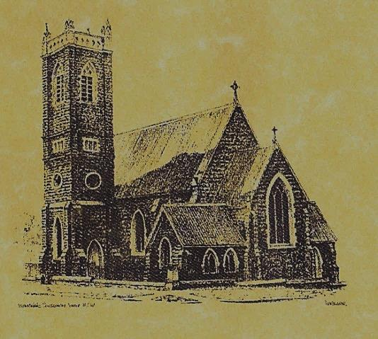

‘CLERGY’
Fr. Michael Mullen (Residing Priest)
Fr. George Ogah (Administrator)

‘PARISH SECRETARY’
Anna Quinn
Phone: 02 69474599
Fax: 02 69474602
Email: tumut@cg.org.au
Web: www.cg.org.au/tumut
Office hours: Wednesday & Friday 9am -12noon
-------------------------------------------------------- ‘WEEKEND MASS TIMES’
Saturday Vigil: 6.pm
Sunday: 10am

‘THIS WEEKS MASS TIMES’
Tuesday: 6pm in Chapel
Wednesday: 10am (School Mass)
Thursday & Friday: 8am in Chapel

‘RECONCILIATION’
Saturday at 5.15pm

‘LITURGY MEETING’
Tuesday: 2.00pm in Chapel

‘PRAYER GROUP’
(Rosary & Divine Mercy)
Wednesday: 2.00pm in Chapel

‘CONTACTS’
Care Group: Anne Huebner 69473406

23rd Sunday in Ordinary Time Year B
September 9th 2018

Gospel Acclamation
Alleluia, alleluia! Jesus preached the Good News of the kingdom and healed all who were sick. Alleluia!

Responsorial Psalm
Praise the Lord, my soul!
Entrance Antiphon
You are just, O Lord, and your judgement is right; treat your servant in accord with your merciful love.
Gospel Acclamation
-----------------------------------
Alleluia, alleluia! Tomorrow the wickedness of the earth will be destroyed; the Saviour of the world will be our king. Alleluia!

T THIS WEEK Saturday & Sunday 8th & 9th September

Ministry | Saturday Vigil 6pm | Sunday 10am
Acolyte | Anita Mason | Sue Bulger
Reader | Kathy Shanahan | Pat Spannagle
Commentator | Maureen Cook | Howard Young
Children’s Liturgy | ---------- | Caitlin Larter
Musicians | Anna Quinn | Patricia & Monica
Altar Servers
Church Care  ________________________  LINEN Maria Cobden | ----------------------------------------
NEXT WEEK Saturday & Sunday 15th & 16th September
Ministry | Vigil 6pm |  | 10am
Acolyte | Tony Butler |  | Dave Shedden
Reader | Liz Boxall |  | Rodney Little
Commentator | Patricia Wilks |  | Joanne Little
Children’s Liturgy | ---------- |  | Pat Spannagle
Musicians | Patricia & Monica |  | Anna Quinn
Altar Servers
Church Care | Group 2: Anna, Pat, Sophie & Fabiana
Feast DayWishing all ouFEASTS DAYS
R O S T E R S
Feast Days 13th Sept: Saint John Chrysostom 14th Sept: Exaltation of the Holy Cross 15th Sept: Our Lady of Sorrows
COLLECTION AMOUNTS FOR AUGUST 2018
1st: $2491.30 2nd: $4373.90 D/D: $1455.00
~PARISH NEWS~
SATURDAY MORNING MASS will be in recess during the month of September. FATHERS DAY APPEAL Collection for retired priests: please make your kind contribution at this weekends Masses in the envelope provided, all gifts are tax deductible. BAPTISMS we welcome into our community this weekend Olivia Jane McCormick daughter of Joseph and Ellen and Gus Thomas McDermott son of Simon and Lisa. We Pray for all baptism families. SONGS OF PRAISE will be held at the Seven Day Adventist Church next Sunday the 16th September at 7pm. Supper will be served at conclusion of evening, could those attending please bring a plate to share. MARION PROCESSION AND YOUTH PILGRIMAGE 2018 will be held on Sunday 14th October at St. Clement’s Retreat Galong, with the procession to the grotto starting at 2pm. See flyer on notice board for more information. PLENARY COUNCIL 2020: “Listen to what the Spirit is saying” Pope Francis has approved the Australian Bishop’s decision to hold a Plenary Council in Australia in 2020 and 2021. It is a significant moment for the Church in Australia to make decisions about the future. To prepare the agenda for the Council, all of the parishioners are invited to reflect on the question: “What do you think God is asking of us in Australia at this time?” Information about the Western Deanery Plenary Council is provbided on the table at the back of the Church. SPECIAL THANKS to our dedicated parishioner DAVID WILKS for servicing our vacuum cleaners.

We pray for those who have gone before us marked with the sign of faith:
MASS HAS BEEN REQUESTED FOR:
Sr. Dorothy Bray RSM, Jim Lynch, Paul Kelly, Chris Ballard, Van de Brug families, Breward families, Frank, Eileen & Marie Malone, Louis Shallow, John Callister, Maude Kelly, Leo Aarts, Maria Tran, Mick Bristow, Maureen Court, Andrew Sturt., Brian Rosetta, Hassel & Joy McGrath, Noel Cook, Rudi & Filomena Comai, Gus & Kath Clout, Ab & Mildred Shanahan, Ina Clout, Pat Malone, Joan Malone, Frank Delany, Ken & Brian Gee, Max Butler, Imelda, Bede & Francis McInerney, John Hourigan, Russell & Peter Ritchie, Peter Bush, Alan Guthrie, Jim McInerney, Kath Stuckey, Iris Stuckey, Minnie Murphy, Alfred & Bridget Claffey, John Marzol, Sean Gordon, Maureen Ashleigh, Tom Sturt, Edward Mary & Clem Malone, Pat Malone, Reg & Mary Madigan, Matt Downing, Wilkinson & Downing families, Frank Stanfield, James Kelly, Tom & Dorothy French.

