Immaculate Conception Parish

P O BOX 600 Tumut
Catholic Community
Collection amounts for January 2016 ~PARISH NEWS~
~ PARISH NEWS ~
~ GOSPEL REFLECTION ~

To whom can we go? You have the words of eternal life.
If we have trouble understanding and coming to terms with some of the teachings of Jesus in the gospel, then we can take some comfort from the reaction of the disciples in today’s gospel. It seems that it was not only the members of the Jewish synagogue who were offended by his teaching, but also those who had accepted Jesus as Messiah or Christ and had joined the community of believers.
“This teaching is difficult; who can accept it?” they complain. Once more, Jesus’ response introduces new teaching, teaching that can only raise more questions in their minds. He links “spirit” with “life”. Having used the term “flesh” of his body and of the life that he offers to those who eat of his flesh, he now introduces an element of doubt: flesh is now “useless”! It is typical of John to use the same word in a variety of ways. Here “flesh” is used negatively and metaphorically to refer to human weakness and sinfulness in contrast with “spirit” which evokes the creative spirit of God that moved over the waters at creation and the spirit that informed the word of the prophets. An excerpt by Sr. Veronica Lawson

PLENARY COUNCIL PRAYER
Come, Holy Spirit of Pentecost. Come, Holy Spirit of the great South Land. O God, bless and unite all your people in Australia and guide us on the pilgrim way of the Plenary Council. Give us the grace to see your face in one another and to recognise Jesus, our companion on the road. Give us the courage to tell our stories and to speak boldly of your truth. Give us ears to listen humbly to each other and a discerning heart to hear what you are saying. Lead your Church into a hope-filled future, that we may live the joy of the Gospel. Through Jesus Christ our Lord, bread for the journey from age to age. Amen. Our Lady Help of Christians, pray for us. Saint Mary MacKillop, pray for us.

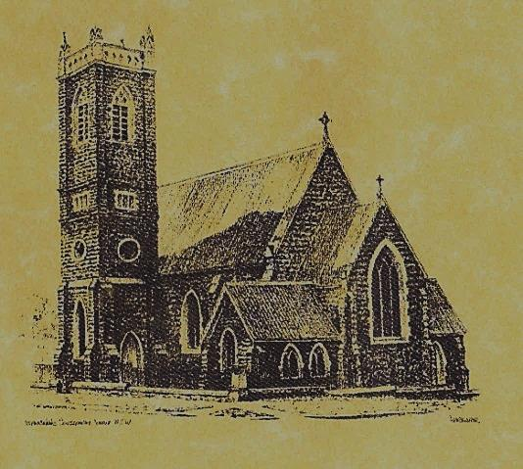

‘CLERGY’
- Fr. Sijo Jose (Parish Priest)
- Fr. George Ogah (Assistant Priest)

‘PARISH SECRETARY’
Anna Quinn
Phone: 02 69474599
Fax: 02 69474602
Email: tumut@cg.org.au
Web: www.cg.org.au/tumut
Office hours: Wednesday & Friday 9am -12noon
-------------------------------------------------------- ‘WEEKEND MASS TIMES’
Saturday Vigil: 6.pm
Sunday: 10am

‘THIS WEEKS MASS TIMES’
Tuesday: 6pm in Chapel
Wednesday: 10am (School Mass)
Thursday & Friday: 8am in Chapel
Saturday: 9am (every fortnight – Thursday: 11am BUPA Liturgy Saturday: 9.40am BLAKENEY LODGE Liturgy)
‘ROSARY’
Saturday at 8.45am Exposition at 8.30am (1st Sat of month)
‘RECONCILIATION’
Saturday at 5.15pm
‘LITURGY MEETING’
Tuesday: 2.00pm in Chapel
‘PRAYER GROUP’
(Rosary & Divine Mercy)
Wednesday: 2.00pm in Chapel
‘CONTACTS’
Care Group: Anne Huebner 69473406

21st Sunday in Ordinary Time Year B
August 26th 2018

Gospel Acclamation
Alleluia, alleluia! Yours words, Lord, are spirit and life; you have the words of everlasting life. Alleluia!

Responsorial Psalm
Taste and see the goodness of the Lord.
Entrance Antiphon
Turn your ear, O Lord, and answer me; save the servant who trusts in you, my God. have mercy on me, O Lord, for I cry to you all the day long.
Gospel Acclamation
-----------------------------------
Alleluia, alleluia! Tomorrow the wickedness of the earth will be destroyed; the Saviour of the world will be our king. Alleluia!

T THIS WEEK Saturday & Sunday 25th & 26th August

Ministry | Saturday Vigil 6pm | Sunday 10am
Acolyte | Anne Huebner | Anita Mason
Reader | School Mass | Mark Hogan
Commentator | School Mass | Pat Spannagle
Children’s Liturgy | ---------- | Kerrin Henderson
Musicians | Anna & Maureen | Patricia & Monica
Altar Servers
Church Care  ________________________  LINEN Bev Piper | ----------------------------------------
NEXT WEEK Saturday & Sunday 1st & 2nd September
Ministry | Vigil 6pm |  | 10am
Acolyte | Barry Madigan |  | Tony Butler
Reader | First Eucharist |  | Kath Rosetta
Commentator | First Eucharist |  | Howard Young
Children’s Liturgy | ---------- |  | Pat Spannagle
Musicians | Anna & Maureen |  | Patricia & Monica
Altar Servers
Church Care | Group 1: Claire, Anne Hickson, Bev & Sophie
Feast DayWishing all ouFEASTS DAYS
R O S T E R S
Feast Days 27th Aug: Saint Monica 28th Aug: Saint Augustine 29th Aug: Passion of Saint John the Baptist Lord, we thank you for our family. Bless each one of us in our uniqueness and let us use our gifts and talents to ensure unity and love within our family now and always. WMF2018
~PARISH NEWS~
FR. SIJO has been appointed as the Parish Priest of Temora. He will celebrate his last Mass in our parish on Sunday 2nd September. A collection for Fr. Sijo’s farewell will be taken up at this weekends Masses followed by a morning tea after the 10am Mass on Sunday 2nd September. SACRAMENT OF FIRST HOLY COMMUNION will be celebrated at the Vigil Mass Saturday 1st September at 6pm. We pray for the candidates and their families. FATHER’S DAY APPEAL Collection for retired priests: There are 23 priests of our Archdiocese who come under the care of the Clergy Retirement Foundation. This appeal raises much needed funds to meet the needs of these priests and to give them security in their retirement years. Please make your kind contribution at next weekends Masses – 1st & 2nd September, in the envelope provided, all gifts are tax deductible. SONGS OF PRAISE preparation has commenced for this event. which will be held at the Seven Day Adventist Church on Sunday 16th September at 7pm. Practice will be in the chapel on Tuesdays at 5.20pm. All interested singers welcome. WORLD MEETING OF FAMILIES 2018 will run from 21st to 26th August. Dublin, Ireland has been chosen by Pope Francis to host this special meeting. MANY THANKS to our McAuley Stage 2 students and teachers for presenting the Vigil Mass this weekend.

We pray for those who have gone before us marked with the sign of faith:
MASS HAS BEEN REQUESTED FOR:

Jim Lynch, Paul Kelly, Chris Ballard, Van de Brug families, Breward families, Frank, Eileen & Marie Malone, Louis Shallow, John Callister, Maude Kelly, Leo Aarts, Maria Tran, Andrew Leyden, Sr. Nolan R.S.M. Mick Bristow, Maureen Court, Andrew Sturt., Brian Rosetta, Sr. Valerian, Hassel & Joy McGrath, Noel Cook, Rudi & Filomena Comai, Gus & Kath Clout, Ab & Mildred Shanahan, Ina Clout, Pat Malone, Joan Malone, Frank Delany, Ken & Brian Gee, Max Butler, Imelda, Bede & Francis McInerney, Cecilia Haddad, John Hourigan, Russell & Peter Ritchie, Kerry Letts, Eileen Creighton, Muriel Maidwell, Thomas Maidwell, Margaret Anne Reardon, Steph Scott, Peter Bush, Alan Guthrie, Jim McInerney, Kath Stuckey, Iris Stuckey, Minnie Murphy, Alfred & Bridget Claffey, John Marzol, Sean Gordon, Maureen Ashleigh, Tom Sturt, Winifred Whitacker, Edward Mary & Clem Malone, Pat Malone, Hickson & O’Sullivan families, Reg & Mary Madigan, Matt Downing, Wilkinson & Downing families, Frank Stanfield, Peter Heffernan, Tim & Amy Twomey, Tom & Merle Arentz, Harriet & Ruben Arentz, Kevin & Nola Arentz, Natalie Baker, Bert & Teresa Butler, James Kelly, Tom & Dorothy French.

