Immaculate Conception Parish

P O BOX 600 Tumut
Catholic Community
Collection amounts for January 2016 ~PARISH NEWS~
~ PARISH NEWS ~
~ GOSPEL REFLECTION ~

Today’s gospel has particular relevance for all in positions of authority, whether as teachers or leaders of organisations or communities. Appointment or election to such positions is not for the sake of status or self-aggrandizement. Neither does the specialised knowledge associated with such roles bring with it the right to special privileges. Sadly, both civic and religious leaders can easily develop a sense of entitlement that shifts the exercise of their authority from service to privilege and oppression. That seems to have been the case for certain religious leaders in first century Palestine.
Within Second Temple Judaism, the Pharisees were the respected teachers and interpreters of the Law of Moses. Some of them abused their positions and so became the subject of Jesus’ scathing and cumulative criticism. They exploited their specialised knowledge to exercise power over the people and create intolerable burdens while at the same time failing to observe their own rules. They sought the adulation of the people through their exaggerated and ostentatious observance of certain religious customs. They are accused of broadening their phylacteries, the little leather boxes containing the words of the Shema (Deuteronomy 6:5) that observant Jews bound to their heads and arms, and of lengthening the tassles attached to their cloaks (in observance of Deuteronomy 22:12). They looked for special treatment, for places and titles of honour, and for public recognition.
Matthew attaches to this condemnation of the scribes and Pharisees several loosely connected sayings of Jesus that link service and humility. Greatness lies, not in the pursuit of power over others, but rather in knowing one’s proper place in the scheme of things and so recognising that God is the source of all human power and authority. In Treading Lightly: The Hidden Wisdom of the World’s Oldest People, Karl-Erik Svelby and Tex Skuthorpe demonstrate how the story of one indigenous community, the Nhunngabarra, offers a compelling alternative to hierarchical leadership in our times, namely the age-old “context-specific” leadership for sustainability. Treading Lightly offers a vision utterly congruent with the gospel-inspired earth-conscious leadership of Pope Francis. An excerpt by Sr. Veronica Lawson
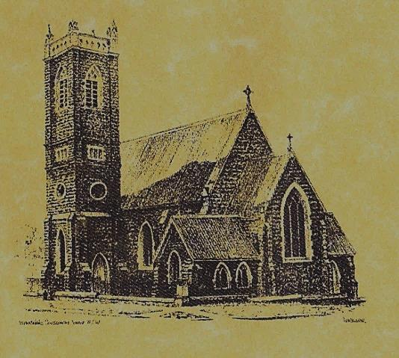

‘CLERGY’
- Fr. Sijo Jose (Parish Priest)
- Fr. Luke Verrell (Assistant Priest)

‘PARISH SECRETARY’
Anna Quinn
Phone: 02 69474599
Fax: 02 69474602
Email: tumut@cg.org.au
Web: www.cg.org.au/tumut
Office hours: Wednesday & Friday 9am -12noon
---------------------------------------------------------
‘WEEKEND MASS TIMES’
Saturday Vigil: 6.00pm
Sunday: 10am (Children’s Liturgy)
Talbingo Sunday: 8.00am
‘THIS WEEKS MASS TIMES’
Tuesday: 6pm
Wednesday: 10am (School Mass)
Thursday: 8am Friday: 6pm
Saturday: 9am (every fortnight - Thursday: 11am BUPA Liturgy
Saturday: 9.40am BLAKENEY LODGE Liturgy)
‘ROSARY’
Saturday at 8.45am
Exposition at 8.30am (1st Sat of month)
‘RECONCILIATION’
Saturday at 5.15pm
‘LITURGY MEETING’
Tuesday: 2.00pm in Chapel
‘PRAYER GROUP’
(Rosary & Divine Mercy)
Wednesday: 2pm in Chapel
‘CONTACTS’
Care Group: Anne Huebner 69473406

Entrance Antiphon
Forsake me not, O Lord, my God; be not far from me! Make haste and come to my help, O Lord, my strong salvation.

Gospel Acclamation
Alleluia, alleluia! You have one Father, your Father in heaven; you have one teacher; the Lord Jesus Christ! Alleluia!

Responsorial Psalm
In you Lord, I have found my peace.
31st Sunday in Ordinary Time
Year A
November 5th 2017

Gospel Acclamation
-----------------------------------
Alleluia, alleluia! Tomorrow the wickedness of the earth will be destroyed; the Saviour of the world will be our king. Alleluia!

T THIS WEEK Saturday & Sunday 4th & 5th November

Ministry | Saturday Vigil 6pm | Sunday 10am
Acolyte | Christine Kelly | Cath Purcell
Reader | Anita Mason | Howard Young
Commentator | Shirley Kenny | Patricia Wilks
Children’s Liturgy | ---------- | Kerrin Henderson
Musicians | Patricia & Monica | Maureen Norman
Altar Servers | To be advised | To be advised
Church Care  ________________________  LINEN Maria Cobden | -----------------------
NEXT WEEK Saturday & Sunday 11th & 12th November
Ministry | Vigil 6pm |  | 10am
Acolyte | Barry Madigan |  | Dave Shedden
Reader | Cath Purcell |  | Anne Huebner
Commentator | Mary Kelly |  | John Power
Children’s Liturgy | ---------- |  | Kirsty Beavan
Musicians | Maureen Norman |  | Patricia & Monica
Altar Servers | To be advised |  | To be advised
Church Care | Group 5: Sandra, Maria & Margaret Dean
Feast DayWishing all our wonderful dads a Happy Father’s Day
R O S T E R S
COLLECTION AMOUNTS FOR OCTOBER 2017
1st: $2179.55 2nd: $1487.25 D/D: $1600.00
Feast Days 10th November: Saint Leo the Great 11th November: Saint Martin of Tours
~ ~ ~ He who recognises no humanity in others, loses it in himself. Author unkown
~PARISH NEWS~
MEMORIAL MASS Friday 10th November at 6pm for our departed relatives and friends. There will be no 8am Mass on this day. MASS INTENTION ENVELOPES are available for your November Mass requests, please take one. SONGS OF PRAISE many thanks to the ecumenically minded dedicated group who represented our parish community last Sunday evening at the Tumut Valley Community Church. Thank you for you participation and involvement. TUMUT COMMUNITY CHRISTMAS DAY LUNCHEON Preparations are happening for this event, and the working group is looking for additional volunteers to help on the day, and/or as a lead up to Christmas. If you are interested in being involved, please contact Patricia on 0401472161. BAPTISMS we welcome into our community this weekend Kayden Richard Poll son of Grant and Megan and Benjamin Robert Symons son of Danny and Michelle. We pray for all baptism families. CHURCH CLEANERS as we have had no response asking for more volunteers, we are going to trial cleaning the church once a fortnight starting this weekend, your name will appear on the bulletin when it is your turn. SPECIAL THANKS to our faithful volunteer this weekend ~Christine Kelly~ FOR SALE - 2018 Daily Mass books $22.00@ and Columban Calendars $8.20@

We pray for those who have gone before us marked with the sign of faith:
MASS HAS BEEN REQUESTED FOR:
Joan Malone, Ken & Brian Gee & family members, Rudi & Filomena Comai, Marallo & Comai families, Celia Mullaly, Sr. Mary Francis Daly, Sr. Mary Jo Wells, Sr. Lorna Woodroff, Jim McInerney, Kath Stuckey, Gus & Kath Clout, Ab & Mildred Shanahan, Ina Clout, Timothy Blakeney, Madeling Fenn, Jan Salan, Chris Ballard, Maude Kelly, Hector, Annie & Kevin Turner, Russell & Peter Ritchie, Norma Leyden, Russell Breward, Maria & Hans Van de Brug, Reg Millgate, Joan Liddell, Lois Shallow, Helen Corbett, Frank, Eileen & Marie Malone, Edward, Marcy & Clem Malone, Frank Stanfield, John Callister, Imelda, Bede & Francis McInerney, Teresa Butler, Joan Stockwell, Emmet Donovan, Hassel McGrath, Noel Cook, Leo & Elvie Holt, Lionel & Tereasa Holt, Hugh Oliver, Pat Malone, Jim Whitaker, Matt & Edith Downing, Con & Ennis Twomey, Pauline Shedden, John Hourigan, Tom & Dorothy French and James Kelly.

