~ GOSPEL REFLECTION ~
Immaculate Conception Parish

P O BOX 600 Tumut
Catholic Community
Collection amounts for January 2016 ~PARISH NEWS~
~ PARISH NEWS ~

Today’s Gospel reading directly follows last week’s Gospel in which Jesus taught the disciples how to handle disputes and conflict within the Christian community. In today’s reading, Peter asks Jesus how many times one ought to extend forgiveness to another. Peter proposes a reasonable number of times, perhaps seven. Jesus replies by extending Peter’s proposal by an enormous amount; not just seven times should one forgive, but 77 times. The parable of the unforgiving servant is Jesus’ elaboration of his initial reply to Peter. Through the parable, we come to understand the depths of God’s mercy toward us and the results of our acceptance of God’s forgiveness. The king in the parable decides to settle accounts with his servants. We are told that one servant in particular owes the king an enormous sum of money. Despite the promise of the servant, it is unlikely that he would ever be able to repay the debt that he owes. The king is moved by the humility of the pleading servant and mercifully forgives the debt. Rather than displaying gratitude for this forgiveness, the servant confronts a fellow servant who owes him a small debt—a pittance when compared with the amount that was owed to the king. The unmerciful servant refuses the pleas of his fellow servant and sends the servant to prison. A few other servants tell the merciful king about the actions of the unforgiving servant. The king punishes the servant because he refused to show the kind of mercy he had himself received from the king. Jesus concludes by indicating that this is how it will be with God and those who refuse to forgive one another.
There is a temptation to quantify forgiveness as Peter tried to do, but Jesus’ point is that forgiveness is not about quantity—the number of times we extend forgiveness to another. In the parable, the king’s forgiveness is like God’s forgiveness, and it transforms us, helping us to be as forgiving as God. The lesson is clear: If we hoard God’s mercy while showing no mercy to others, we risk forfeiting the effects of God’s mercy in our lives. An excerpt from the Catholic Archdiocese of Kota Kinabalu
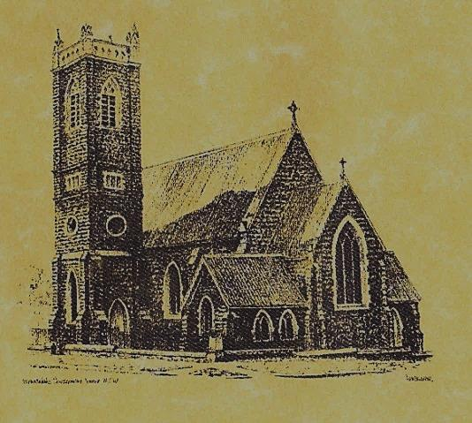

‘CLERGY’
- Fr. Sijo Jose (Parish Priest)
- Fr. Luke Verrell (Assistant Priest)

‘PARISH SECRETARY’
Anna Quinn
Phone: 02 69474599
Fax: 02 69474602
Email: tumut@cg.org.au
Web: www.cg.org.au/tumut
Office hours: Wednesday & Friday 9am -12noon
---------------------------------------------------------
‘WEEKEND MASS TIMES’
Saturday Vigil: 6.00pm
Sunday: 10am (Children’s Liturgy)
Talbingo Sunday: 8.00am
‘THIS WEEKS MASS TIMES’
Tuesday: 6pm
Wednesday: 10am (School Mass)
Thursday & Friday: 8am
Saturday: 9am (every fortnight - Thursday: 11am BUPA Liturgy
Saturday: 9.40am BLAKENEY LODGE Liturgy)
‘ROSARY’
Saturday at 8.45am
Exposition at 8.30am (1st Sat of month)
‘RECONCILIATION’
Saturday at 5.15pm
‘LITURGY MEETING’
Tuesday: 2.00pm in Chapel
‘PRAYER GROUP’
(Rosary & Divine Mercy)
Wednesday: 2pm in Chapel
‘CONTACTS’
Care Group: Anne Huebner 0406490415

Gospel Acclamation
Alleluia, alleluia! I give you a new commandment; love one another as I have loved you. Alleluia!

24th Sunday in Ordinary Time
Year A
September 17th 2017

Entrance Antiphon
Give peace, O Lord, to those who wait for you, that your prophets be found true. Hear the prayers of your servant, and of your people Israel.

Responsorial Psalm
The Lord is kind and merciful; slow to anger, and rich in compassion.
Gospel Acclamation
-----------------------------------
Alleluia, alleluia! Tomorrow the wickedness of the earth will be destroyed; the Saviour of the world will be our king. Alleluia!

T THIS WEEK Saturday & Sunday 16th & 17th September

Ministry | Saturday Vigil 6pm | Sunday 10am
Acolyte | Cath Purcell | Mark Hogan
Reader | Evelyn Heffernan | Monica Webb
Commentator | Shirley Kenny | John Power
Children’s Liturgy | ---------- | Caitlin Larter
Musicians | Maureen Norman | Anna Quinn
Altar Servers | Jessica & Emily Kelly | Chloe Turnbull & Lily Webb
Church Care  ________________________  LINEN Maria Cobden | Group 3: Yvonne, Lee, Mary, Colleen & Kath
NEXT WEEK Saturday & Sunday 23rd & 24th September
Ministry | Vigil 6pm |  | 10am
Acolyte | Anne Huebner |  | Peter Malone
Reader | School Mass |  | Sue Bulger
Commentator | School Mass |  | Howard Young
Children’s Liturgy | ---------- |  | Pat Spannagle
Musicians | Anna Quinn |  | Patricia & Monica
Altar Servers | Abby Crampton & Olivia Dean |  | Darcy Halloran & Charlotte Kelly
Church Care | Group 4: The Dobbie family
Feast DayWishing all our wonderful dads a Happy Father’s Day
R O S T E R S
FEAST DAYS 21st September: Saint Matthew 23rd September: Saint Pius of Pietrelcina
SPECIAL THANKS to our Vigil Mass reader ~ Evelyn Heffernan ~
~ ~ ~
For many of us, God’s presence is expressed in different ways. Often it is a sense of peace. Chaim Bentorah
~PARISH NEWS~
SACRAMENT OF 1ST RECONCILIATION we congratulate the children who received this special sacrament last Thursday evening. Many thanks to Anita Mason, Patricia Spannagle, Maria Long and parents for preparing the children. CATHOLIC VOICE September edition is now available. BAPTISM we welcome into our community this weekend Angus Thomas McDonell son of Thomas and Madison. We pray for all baptism families. DYE FAMILY REUNION the family of Alfred Robert and Mary Bridget Dye who lived in Tumut from 1904 – 1920 will be having a reunion on the weekend of 30th September/1st October 2017. If you have a connection with the Dye family please make yourselves know to them after the 10am Mass on Sunday 1st October. PREVENTING EUTHANASIA & ASSISTED SUICIDE The NSW Parliament is likely to consider a private members Bill to legalise euthanasia and assisted suicide. If this is accepted, it would radically abandon our deep human commitment not to deliberately take someone’s life. Therefore, we urge all parishioners to reject this Bill and please sign the petition in the church foyer.

We pray for those who have gone before us marked with the sign of faith especially: RECENTLY DECEASED: Madeline Fenn
MASS HAS BEEN REQUESTED FOR:

Jan Salan, Chris Ballard, Maude Kelly, Hector, Annie & Kevin Turner, Russell & Peter Ritchie, Norma Leyden, Russell Breward, Maria & Hans Van deBrug, Reg Millgate, Joan Liddell, Lois Shallow, Helen Corbett, Frank, Eileen & Marie Malone, Edward, Marcy & Clem Malone, Frank Stanfield, John Callister, Imelda, Bede & Francis McInerney, Teresa Butler, Joan Stockwell, Emmet Donovan, Rudi & Filomena Comai, Hassel McGrath, Noel Cook, Leo & Elvie Holt, Lionel & Tereasa Holt, Hugh Oliver, Pat Malone, Jim Whitaker, Matt & Edith Downing, Con & Ennis Twomey, Pauline Shedden, Bob & Sheila Wortes, Robert & Gertrude Tuncks, Ron & Pauline Hamilton, John Hourigan, Brian Gee, Alan & Angela Guthrie, Artie & Dulcie Piper, Tom, Kevin, Ruben & Harriett Arentz, Kevin Hawthorn, Kevin, Marie & Ray Cowan, Alfred & Bridget Claffey, Anna Do, Stan Kenny, Tom & Dorothy French and James Kelly.

