~ GOSPEL REFLECTION ~
Immaculate Conception Parish

P O BOX 600 Tumut
Catholic Community
Collection amounts for January 2016 ~PARISH NEWS~
~ PARISH NEWS ~

The church knows metaphorically what it means to be ‘battered by the waves’. Over its two millennia history, there have been periods of discrimination and persecution against its members. Countless church members have died for their faith, while others have been denied the freedom to practice their religion. There have also been times when the church has fallen far short of its own ideals and has quite seriously betrayed the gospel values it seeks to embody and proclaim. It is presently ‘battered’ by huge even terrifying waves, largely of its own creating. Only God can bring order out of the chaos, and God works through the courageous hearts and hands of faith-filled disciples.
In today’s gospel, Matthew tells of Jesus astride the waves like the God of Israel (Job 9:8). In Israel’s mythology, the sea represents chaos. To walk on water is to have power and authority to bring order out of the chaos. Matthew presents Jesus as exercising the power of God over the potentially destructive chaos. Jesus makes his claim to divine power explicit in words that echo God’s words from the burning bush: ‘It is I’ (literally ‘I am’). He tells the frightened disciples to take heart and not to be afraid. Peter, leader of the group, continues to doubt. He asks for a sign and is then prepared to take a risk in order to come to Jesus on the water. He begins to falter when he takes his eyes off Jesus and focuses instead on the threatening wind. Jesus reaches out his hand to rescue Peter. In a lovely gesture, Jesus takes him by the hand and holds him firmly in his grip. Jesus names Peter’s problem as one of limited faith.
Matthew weaves the story of Peter into an earlier story from Mark’s gospel. We can only speculate on the reasons for this. Were Matthew’s communities going through a hard time? Were they battered by the waves of conflicting loyalties as they found themselves excluded from Pharisaic Judaism? Was the pressure of separation from the synagogue too great for some, even for those in leadership? This is a telling story for anyone who exercises leadership at any level in the church. It is a reminder to us as disciples to keep our eyes firmly fixed on the source of hope in times of struggle and uncertainty. Finally, this story invites us to consider the uncontrollable waves we are creating by our reluctance to address the causes of climate change.
An excerpt by Sister Veronica Lawson
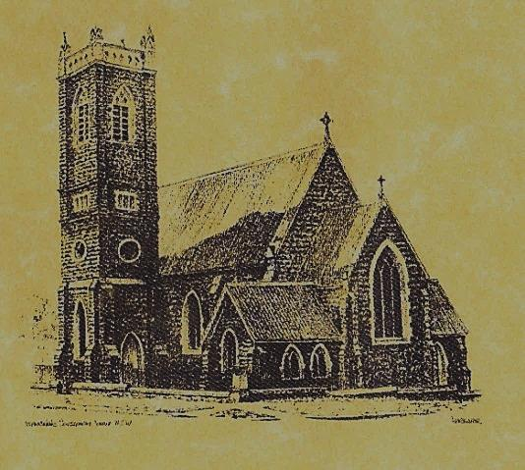

‘CLERGY’
- Fr. Sijo Jose (Parish Priest)
- Fr. Luke Verrell (Assistant Priest)

‘PARISH SECRETARY’
Anna Quinn
Phone: 02 69474599
Fax: 02 69474602
Email: tumut@cg.org.au
Web: www.cg.org.au/tumut
Office hours: Wednesday & Friday 9am -12noon
---------------------------------------------------------
‘WEEKEND MASS TIMES’
Saturday Vigil: 6.00pm
Sunday: 10am (Children’s Liturgy)

‘THIS WEEKS MASS TIMES’
Tuesday: 10am
Wednesday: 10am (School Mass)
Thursday & Friday: 8am
Saturday: 9am (every fortnight - Thursday: 11am BUPA Liturgy
Saturday: 9.40am BLAKENEY LODGE Liturgy)
‘ROSARY’
Saturday at 8.45am
Exposition at 8.30am (1st Sat of month)
‘RECONCILIATION’
Saturday at 5.15pm
‘LITURGY MEETING’
Tuesday: 2.00pm in Chapel
‘PRAYER GROUP’
(Rosary & Divine Mercy)
Wednesday: 2pm in Chapel
‘CONTACTS’
Care Group: Anne Huebner 0406490415

Responsorial Psalm
Lord, show us your mercy and love, and grant us your salvation.
Entrance Antiphon
Look to your covenant, O Lord, and forget not the life of your poor ones for ever. Arise, O God, and defend your cause, and forget not the cries of those who seek you.

Gospel Acclamation
-----------------------------------
Alleluia, alleluia! Tomorrow the wickedness of the earth will be destroyed; the Saviour of the world will be our king. Alleluia!

Gospel Acclamation
Alleluia, alleluia! I hope in the Lord, I trust in his word. Alleluia!

19th Sunday in Ordinary Time
Year A
August 13th 2017

T THIS WEEK Saturday & Sunday 12th & 13th August

Ministry | Saturday Vigil 6pm | Sunday 10am
Acolyte | Barry Madigan | Trish Matthews
Reader | Claire Cole | Pat Spannagle
Commentator | Shirley Kenny | John Power
Children’s Liturgy | ---------- | Fran Butler
Musicians | Maureen Norman | Patricia & Monica
Altar Servers | Gabbi & Maggi Dalisay | Abby Crampton & Olivia Dean
Church Care  ________________________  LINEN Jo Little | Group 3: Yvonne, Lee, Mary, Colleen Kath & Brian
NEXT WEEK Saturday & Sunday 19th & 20th August
Ministry | Vigil 6pm |  | 10am
Acolyte | Christine Kelly |  | Mark Hogan
Reader | Anita Mason |  | Kirsty Beavan
Commentator | Maureen Cook |  | Liz Boxall
Children’s Liturgy | ---------- |  | Caitlin Larter
Musicians | Maureen Norman |  | Anna Quinn
Altar Servers | Chloe Turnbull & Lily Webb |  | Annabelle Sturgess & Genevieve Mason-Elliott
Church Care | Group 4: the Dobbie Family
Feast Day
R O S T E R S
Feast Days
14th August: Saint Maximilian Mary Kolbe 15th August: The Assumption of the Blessed Virgin Mary ~ ~ ~
The path of prayer leads to the centre of peace ~Oscar Wilde~

~PARISH NEWS~
FEAST OF THE ASSUMPTION Mass will be at 10am on Tuesday August 15th instead of the evening Mass. PARISH STREET STALL will be held on Friday 18th August 2017 in front of House 2 Home. There are still a few spots available for helpers to man the stall, if you can spare an hour, write your name on the roster in the church foyer or phone Tiffany on 0428239735. Donations of saleable items and home cooking will be much appreciated. Cash donations will also be greatly accepted. Please help make our stall a profitable one. SACRAMENT OF FIRST EUCHARIST will be celebrated at our Vigil Mass on Saturday 26th August. BAPTISM we welcome into our community this weekend Harrison Allan Williams son of Stacy and Adam. We pray for baptism families. CATHOLIC VOICE August edition is now available for your collection. SAVE THE DATE ‘Marian Procession’ Sunday 8th October 2017. Archbishop Christopher extends an invitation to all Catholics of the Archdiocese of Canberra and Goulburn to attend the 2017 Marian Procession at St. Clement’s Monastery Galong. 9am: Youth Pilgrimage from Galong village. 10.30am: Confession 11.30am: Mass with Archbishop Christopher 12.30pm: Lunch 2pm: Procession to the grotto and sharing by Sr. Mary Rachel (OP).

We pray for those who have gone before us marked with the sign of faith:

MASS HAS BEEN REQUESTED FOR:

Edward, Marcy & Clem Malone, Frank Stanfield, John Callister, Imelda, Bede & Francis McInerney, Teresa Butler, Joan Stockwell, Emmet Donovan, Rudi & Filomena Comai, Hassel McGrath, Noel Cook, Leo & Elvie Holt, Lionel & Tereasa Holt, Hugh Oliver, Pat Malone, Jim Whitaker, Matt & Edith Downing, Con & Ennis Twomey, Pauline Shedden, Bob & Sheila Wortes, Robert & Gertrude Tuncks, Ron & Pauline Hamilton, John Hourigan, Brian Gee, Alan & Angela Guthrie, Artie & Dulcie Piper, Tom, Kevin, Ruben & Harriett Arentz, Kevin Hawthorn, Kevin, Marie & Ray Cowan, Russell & Peter Ritchie, Alfred & Bridget Claffey, Ken Gee, Frederick & Mabel McInerney, Tom & Sam Sturt, Anna Do, Stan Kenny, Tom & Dorothy French and James Kelly.

