~ GOSPEL REFLECTION ~
Immaculate Conception Parish

P O BOX 600 Tumut
Catholic Community
Collection amounts for January 2016 ~PARISH NEWS~
~ PARISH NEWS ~
Some time back, my great-nephew met with an unwelcome refusal from his father. His response: ‘Dad, I am not impressed with what I’m hearing!’ Like young Izaak, I suspect that most experienced gardeners and farmers and bakers would have something similar to say at Jesus’ choice of images for the reign of God. They would be particularly unimpressed, I expect, by the methods of the farmer-gardener God presented in today’s gospel reading. Leaving weeds to endanger the wheat crop seems none too smart. Mustard, known for its propensity to grow wild and threaten the life of every other plant in the garden, makes for an equally strange image. God’s reign imaged as a baker woman taking yeast, a substance considered a corrupting influence in the first century Jewish world, and mixing it into twenty kilos of wheat flour, stretches the imagination in other directions.
These images cut across expectations quite dramatically. What do they tell us about God’s kingdom? In the parables of the mustard seed and the leaven, there is a movement from small to great that communicates something about the power of God to bring abundance of life from the most insignificant beginnings. They don’t seem to fit with the parable of the wheat and the weeds until we look a little more closely. The element of danger to the life of the whole is common to all three parables. Maybe Matthew’s Jesus is telling us that God is a God of risk, prepared to allow the weeds and endangering herbs and other dubious substances to ‘infect’ God’s field. Harvest-time will be time enough to divide the wheat from the weeds. In the meantime, the good seed must take hold. In the parables of the mustard seed and the leaven, Jesus may be telling his hearers that their idea of infection or danger is different from his. At one level, he engages the more-than-human and talks about respect for the complexity of eco-systems. At another, he is talking about societal inclusion: the very people that many consider ‘unclean’ or ‘sinful’ or ‘demon-possessed’ are not to be displaced from God’s field or God’s table. On the contrary, they may be the very ones who season the life of the whole. Life is messy after all and God is in the mess. It is worth noting that the leaven parable offers one of the few occasions in the gospel where God is imaged as female. While we are all aware that God is neither male nor female, most of us have been conditioned to use only male images for God. The parable of the woman kneading dough validates the potential of female experience to reflect the life and activity of God in our world.
An excerpt by Veronica Lawson RSM
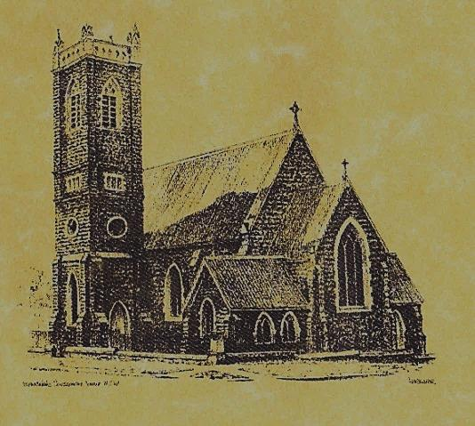

‘CLERGY’
- Fr. Sijo Jose (Parish Priest)
- Fr. Luke Verrell (Assistant Priest)

‘PARISH SECRETARY’
Anna Quinn
Phone: 02 69474599
Fax: 02 69474602
Email: tumut@cg.org.au
Web: www.cg.org.au/tumut
Office hours: Wednesday & Friday 9am -12noon
---------------------------------------------------------
‘WEEKEND MASS TIMES’
Saturday Vigil: 6.00pm
Sunday: 10am (Children’s Liturgy)
‘THIS WEEKS MASS TIMES’
Tuesday: 6pm
Wednesday: 10am (School Mass)
Thursday & Friday: 8am
Saturday: 9am (every fortnight - Thursday: 11am BUPA Liturgy
Saturday: 9.40am BLAKENEY LODGE Liturgy)
‘ROSARY’
Saturday at 8.45am
Exposition at 8.30am (1st Sat of month)
‘RECONCILIATION’
Saturday at 5.15pm
‘LITURGY MEETING’
Tuesday: 2.00pm in Chapel
‘PRAYER GROUP’
(Rosary & Divine Mercy)
Wednesday: 2pm in Chapel
‘CONTACTS’
Care Group: Anne Huebner 0406490415

16th Sunday in Ordinary Time
Year A
July 23rd 2017

Entrance Antiphon
See, I have God for my help. The Lord sustains my soul. I will sacrifice to you with willing heart, and praise your name, O Lord, for it is good.

Gospel Acclamation
Alleluia, alleluia! Blessed are you, father, Lord of heaven and earth; you have revealed to little ones the mysteries of the kingdom. Alleluia!

Responsorial Psalm
Lord, you are good and forgiving.
Gospel Acclamation
-----------------------------------
Alleluia, alleluia! Tomorrow the wickedness of the earth will be destroyed; the Saviour of the world will be our king. Alleluia!

T THIS WEEK Saturday & Sunday 22nd & 23rd July

Ministry | Saturday Vigil 6pm | Sunday 10am
Acolyte | Peter Malone | Cath Purcell
Reader | School Mass | Liz Boxall
Commentator | School Mass | Anne Huebner
Children’s Liturgy | ---------- | Caitlin Larter
Musicians | Anna Quinn | Patricia & Monica
Altar Servers | Ashleigh Oriel & Kayla Crane | Darcy Halloran & Charlotte Kelly
Church Care  ________________________  LINEN Maria Cobden | Group 5: Sandra, Maria & Margaret Dean
NEXT WEEK Saturday & Sunday 29th & 30th July
Ministry | Vigil 6pm |  | 10am
Acolyte | Christine Kelly |  | Mark Hogan
Reader | Carmel Butler |  | Barry Madigan
Commentator | Shirley Kenny |  | Cathy Purcell
Children’s Liturgy | ---------- |  | Pat Spannagle
Musicians | Maureen Norman |  | Patricia & Monica
Altar Servers | Xavier Henderson & Riley Hotham |  | Jessica & Emily Kelly
Church Care | Group 1: Claire, Anne Hickson, Maureen & Bev
R O S T E R S
Feast Days
25th July: Saint James 26th July: Saint Joachim and Anne 29th July: Saint Martha ~ ~ ~
In the end, we will remember not the words of our enemies, but the silence of our friends.
MARTIN LUTHER KING jr.
~PARISH NEWS~
REMINDER there are still a few Plan Giving envelopes boxes that need to be collected. If there are any parishioners who would like to contribute to this plan and do not have envelopes or have been accidentally omitted please contact the parish office – it is not too late. RESOURCES there are a few copies of the new ‘Discover Catholic Rome’ magazine available to interested parishioners in the church foyer, this publication is from the Archdiocese of Sydney who organise unique Rome Pilgrimages throughout the year. Feel free to take and read. SAVE THE DATE our next parish street stall will be held on Friday 18th August 2017. Helpers will be needed to man the stall. Donations of saleable items and home cooking will also be much appreciated. ‘Marian Procession’ Sunday 8th October 2017. Archbishop Christopher extends an invitation to all Catholics of the Archdiocese of Canberra and Goulburn to attend the 2017 Marian Procession at St. Clement’s Monastery Galong. 9am: Youth Pilgrimage from Galong village. 10.30am: Confession 11.30am: Mass with Archbishop Christopher 12.30pm: Lunch 2pm: Procession to the grotto and sharing by Sr. Mary Rachel (OP). SPECIAL THANKS this weekend to McAuley students for presenting the Vigil Mass.

We pray for those who have gone before us marked with the sign of faith especially
RECENTLY DECEASED: Cecilia Mary Alley
MASS HAS BEEN REQUESTED FOR:

Teresa Butler, Emmet Donovan, Rudi & Filomena Comai, Hassel McGrath, Noel Cook, Leo & Elvie Holt, Lionel & Tereasa Holt, Hugh Oliver, Pat Malone, Jim Whitaker, Matt & Edith Downing, Con & Ennis Twomey, Pauline Shedden, Bob & Sheila Wortes, Robert & Gertrude Tuncks, Ron & Pauline Hamilton, John Hourigan, Brian Gee, Alan & Angela Guthrie, Artie & Dulcie Piper, Tom, Kevin, Ruben & Harriett Arentz, Kevin Hawthorn, Kevin, Marie & Ray Cowan, Russell & Peter Ritchie, Alfred & Bridget Claffey, John Marzol, Ken Gee, Frederick & Mabel McInerney, Ken Elliott, Jock Roberts, Ralph Klaus, Tom & Sam Sturt, Harvey Evans, Chris Ballard, Anna Do, Stan Kenny, Tom & Dorothy French and James Kelly.

