~ GOSPEL REFLECTION ~
Immaculate Conception Parish

P O BOX 600 Tumut
Catholic Community
Collection amounts for January 2016 ~PARISH NEWS~
~ PARISH NEWS ~

One of the privileges of my life has been an ongoing involvement in Catholic education, especially in religious and theological education. While my connection now is somewhat removed from the day to day life of schools, I am keenly aware of the selfless dedication of leadership and staff in their efforts to create environments for the children and young adults in our communities to receive God’s word in its multi-layered reality. A sense of wonder and appreciation of the goodness of creation, of respect for the human and the more-than-human Earth community, is at the heart of any truly worthwhile education. The experience of violence or broken trust in the lives of some children may inhibit that sense of wonder and respect. The sensitive educator, at home and at school, is attuned to the diversity of experience among children and is called to attend to the inevitable diversity of needs so that all might be open to learn and to grow in wisdom and grace.

Jesus’ parable of the soil, seed and sower reminds us that the grace of God’s word is there for everyone who is open to receive it. If the seed takes root in rich soil, the harvest is assured. If it misses the mark and falls on the path, the benefit is for the birds alone and not for the human community. If the soil is rocky, the growth is premature and short-lived and the harvest is very limited, so that the birds are deprived along with the human community. If the seed falls among thorns, it is choked-so once again, there is no harvest. The readiness of the soil is all important, though the extraordinary extent of the yield is the measure of God’s abundant grace.
This parable reflects Jesus’ closeness to the whole Earth community and his familiarity with the lives of ordinary people. While scattering of seed before ploughing seems a rather wasteful method of sowing a crop, such a practice is attested in the ancient world. Is the sower an extraordinarily generous God or an exploitative and wasteful estate owner? Parables tease their hearers and invite them to ponder their many levels of meaning. We have to bring our own life experience into dialogue with the word of each parable and search out its meaning for us. When we consider our children, the parable of the soil, seed and sower may yield its wisdom more slowly than parents and teachers may wish. Young people tend to mature at different rates and their faith develops in myriad ways that only God as harvester truly comprehends. We do what we can and trust that God will ensure an abundant harvest.

An excerpt by Veronica Lawson RSM

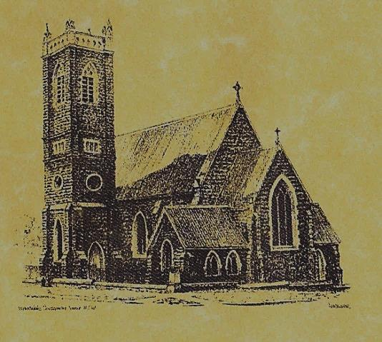

‘CLERGY’
- Fr. Sijo Jose (Parish Priest)
- Fr. Luke Verrell (Assistant Priest)

‘PARISH SECRETARY’
Anna Quinn
Phone: 02 69474599
Fax: 02 69474602
Email: tumut@cg.org.au
Web: www.cg.org.au/tumut
Office hours: Wednesday & Friday 9am -12noon
---------------------------------------------------------
‘WEEKEND MASS TIMES’
Saturday Vigil: 6.00pm
Sunday: 10am (Children’s Liturgy)

‘THIS WEEKS MASS TIMES’
Tuesday: 6pm
Wednesday: 10am (School Mass)
Thursday & Friday: 8am
Saturday: 9am (every fortnight - Thursday: 11am BUPA Liturgy
Saturday: 9.40am BLAKENEY LODGE Liturgy)
‘ROSARY’
Saturday at 8.45am
Exposition at 8.30am (1st Sat of month)
‘RECONCILIATION’
Saturday at 5.15pm
‘LITURGY MEETING’
Tuesday: 2.00pm in Chapel
‘PRAYER GROUP’
(Rosary & Divine Mercy)
Wednesday: 2pm in Chapel
‘CONTACTS’
Care Group: Anne Huebner 0406490415

15th Sunday in Ordinary Time
Year A
July 16th 2017

Entrance Antiphon
Ask for me, in justice I shall behold your face; I shall be filled with the vision of your glory.

Gospel Acclamation
Alleluia, alleluia! The seed is the word of God, Christ is the sower; all who come to him will live for ever. Alleluia!

Responsorial Psalm
The seed that falls on good ground will yield a fruitful harvest.
Gospel Acclamation
-----------------------------------
Alleluia, alleluia! Tomorrow the wickedness of the earth will be destroyed; the Saviour of the world will be our king. Alleluia!

T THIS WEEK Saturday & Sunday 15th & 16th July

Ministry | Saturday Vigil 6pm | Sunday 10am
Acolyte | Trish Matthews | Barry Madigan
Reader | Mary Kelly | Pat Spannagle
Commentator | Dobbie Family | John Power
Children’s Liturgy | ---------- | -----------
Musicians | Maureen Norman | Anna Quinn
Altar Servers | Chloe Turnbull & Lily Webb | Gabbi & Maggie Dalisay
Church Care  ________________________  LINEN Jo Little | Group 4: The Dobbie Family
NEXT WEEK Saturday & Sunday 22nd & 23rd July
Ministry | Vigil 6pm |  | 10am
Acolyte | Peter Malone |  | Cath Purcell
Reader | School Mass |  | Liz Boxall
Commentator | School Mass |  | Anne Huebner
Children’s Liturgy | ---------- |  | Caitlin Larter
Musicians | Anna Quinn |  | Patricia & Monica
Altar Servers | Ashleigh Oriel & Kayla Crane |  | Darcy Halloran & Charlotte Kelly
Church Care | Group 5: Sandra, Maria & Margaret Dean
R O S T E R S
Feast Days
22nd July: Saint Mary Magdalene 25th July: Saint James 26th July: Saints Joachim and Anne 29th July: Saint Martha ~ ~ ~
When I tell the truth, it is not for the sake of convincing those who do not know it, but for the sake of defending those that do. William Blake
Welcome back to McAuley students for Term 3
~PARISH NEWS~
REMINDER there are still a few Plan Giving envelopes boxes that need to be collected. If there are any parishioners who would like to contribute to this plan and do not have envelopes or have been accidentally omitted please contact the parish office – it is not too late. BAPTISM we welcome into our community this weekend Georgiana Lily Lee daughter of Brett and Paige. We pray for baptism families. CATHOLIC VOICE July edition is now available. RESOURCES ‘The Centenary Our Lady of Fatima’ & ‘The Story of Fatima’ are available for you to take and read. Thank you for your thoughts Fr. Mark. SAVE THE DATE our next parish street stall will be held on Friday 18th August 2017. ‘Marian Procession’ Sunday 8th October 2017. Archbishop Christopher extends an invitation to all Catholics of the Archdiocese of Canberra and Goulburn to attend the 2017 Marian Procession at St. Clement’s Monastery Galong. 9am: Youth Pilgrimage from Galong village. 10.30am: Confession 11.30am: Mass with Archbishop Christopher 12.30pm: Lunch 2pm: Procession to the grotto and sharing by Sr. Mary Rachel (OP). SPECIAL THANKS this weekend to our faithful Acolyte Trish Matthews

We pray for those who have gone before us marked with the sign of faith:

MASS HAS BEEN REQUESTED FOR:

Teresa Butler, Rudi & Filomena Comai, Hassel McGrath, Noel Cook, Leo & Elvie Holt, Lionel & Tereasa Holt, Hugh Oliver, Pat Malone, Jim Whitaker, Matt & Edith Downing, Con & Ennis Twomey, Pauline Shedden, Bob & Sheila Wortes, Robert & Gertrude Tuncks, Ron & Pauline Hamilton, John Hourigan, Brian Gee, Alan & Angela Guthrie, Artie & Dulcie Piper, Tom, Kevin, Ruben & Harriett Arentz, Kevin Hawthorn, Kevin, Marie & Ray Cowan, Russell & Peter Ritchie, Alfred & Bridget Claffey, John Marzol, Ken Gee, Frederick & Mabel McInerney, Ken Elliott, Jock Roberts, Ralph Klaus, Tom & Sam Sturt, Harvey Evans, Chris Ballard, Anna Do, Stan Kenny, Tom & Dorothy French and James Kelly.

