~ GOSPEL REFLECTION ~
Immaculate Conception Parish

P O BOX 600 Tumut
Catholic Community
Collection amounts for January 2016 ~PARISH NEWS~
~ PARISH NEWS ~

I was reading a reflection by the Jesuit commentator, Mark Link, and he was speaking about this Gospel message of "taking up one's cross and following Christ" - I must say, that at times I have said to the Lord, "Look, Lord, I will follow you and I will keep your message and values and proclaim it... but this "taking up the cross" and "suffering" thing.... that part!... can we talk about that... maybe re-negotiate it ... I find that difficult!" - I think most people baulk at the idea that there will be pain, loss and suffering in life and in our decision to follow Christ’s ways.
Even Our Lord hesitated at the enormousness of the cross.. at the garden of Gethsemane he prayed that this cup of suffering would be taken from him... but then added (wonderfully) but not my will be done, but yours! Nobody rushes towards suffering or prefers a cross. The mystery of the cross is a difficult but central reality in the life of Christ and of us all..... And in life, there are many little crosses as we journey along our path.........
Mark Link tells a story of a movie he once saw called "American Anthem" - it shows a young man who is having great difficulties coming to terms with the loss of a limb in an accident. The man falls into a deep depression and stays in his room, with curtains drawn, not speaking to others, - passing his time in darkness.... he then contrasts this scene with another incident reported by a man called Robert Bruce... who recounted the day he was walking down a crowded street - He heard the voice of someone singing joyfully.....and when he located the source of this uplifting singing.....He could not believe his eyes.... it was a man without legs, pushing himself along in a wheelchair, and singing joyfully and beautifully at the top of his voice....// it is a reminder that one person's rejection of a cross brought sadness, whilst another person's acceptance of a cross was the source of peace and joy. This is not at all an easy message. This is something that Our Lord not only taught us about, but he also lived this message so wonderfully. An excerpt by Roman Catholic Reflections
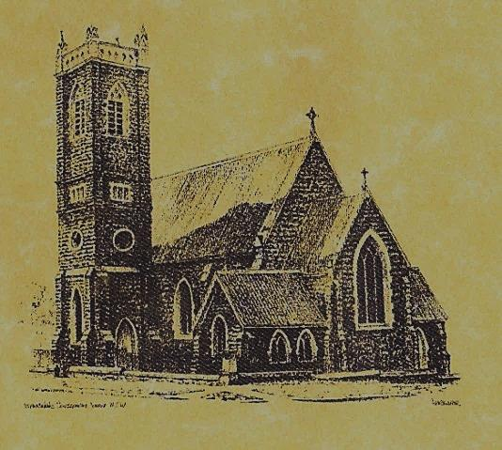
very difficult to accept o

‘CLERGY’
- Fr. Sijo Jose (Parish Priest)
- Fr. Luke Verrell (Assistant Priest)

‘PARISH SECRETARY’
Anna Quinn
Phone: 02 69474599
Fax: 02 69474602
Email: tumut@cg.org.au
Web: www.cg.org.au/tumut
Office hours: Wednesday & Friday 9am -12noon
--------------------------------------------------------
‘WEEKEND MASS TIMES’
Saturday Vigil: 6.00pm
Sunday: 10am
Talbingo Sunday: 8.00am
‘THIS WEEKS MASS TIMES’
Tuesday: 6pm
Wednesday: 10am
Thursday & Friday: 8am
Saturday: 9am (every fortnight - Thursday: 11am BUPA Liturgy
Saturday: 9.40am BLAKENEY LODGE Liturgy)
‘ROSARY’
Saturday at 8.45am
Exposition at 8.30am (1st Sat of month)
‘RECONCILIATION’
Saturday at 5.15pm
‘LITURGY MEETING’
Tuesday: 2pm in Chapel
‘PRAYER GROUP’ Wednesday: 2pm in Chapel
---------------------------------------------------------
‘CONTACTS’
Care Group: Anne Huebner 0269473406

Gospel Acclamation
Alleluia, alleluia! You are a chosen race, a royal priesthood, a holy people. Praise God who called you out of darkness and into his marvellous light. Alleluia!

Responsorial Psalm

For ever I will sing the goodness of the Lord.
Entrance Antiphon

All peoples, clap your hands. Cry to God with shouts of joy!

13th Sunday in Ordinary Time Year A
July 2nd 2017

Gospel Acclamation
-----------------------------------
Alleluia, alleluia! Tomorrow the wickedness of the earth will be destroyed; the Saviour of the world will be our king. Alleluia!

T THIS WEEK Saturday & Sunday 1st & 2nd July

Ministry | Saturday Vigil 6pm | Sunday 10am
Acolyte | Cath Purcell | Mark Hogan
Reader | Trish Matthews | Cathy Shanahan
Commentator | Liz Boxall | Patricia Willks
Children’s Liturgy | ---------- | ------------
Musicians | Patricia & Monica | Maureen Norman
Altar Servers | Jack Stewart & TBC | Dana Perry & Jessie Raftery
Church Care  ________________________  LINEN Marie Ambrose | Group 2: Cathy, Anna, Pat Cheryl & Rhonda
NEXT WEEK Saturday & Sunday 8th & 9th July
Ministry | Vigil 6pm |  | 10am
Acolyte | Anita Mason |  | Dave Shedden
Reader | Kirsty Beavan |  | Rod Little
Commentator | Marueen Cook |  | Jo Little
Children’s Liturgy | ----------- |  | ------------
Musicians | Maureen Norman |  | Patricia & Monica
Altar Servers | TBC |  | TBC
Church Care | Group 3: Yvonne, Lee, Mary, Colleen Kath & Brian
R O S T E R S

FEAST DAY 3rd July: Saint Thomas
~ ~ ~
COLLECTION AMOUNTS FOR JUNE 2017
1st $1993.20 2nd $4347.50 D/D $1740.00 Talbingo $100.00 Easter dues final $842.95
~PARISH NEWS~
REMINDER there are still a few Plan Giving envelope boxes that need to be collected. PLAN GIVING ENVELOPES please note that envelope numbers have changed for most parishioners; therefore it would be much appreciated not to use your existing envelopes after 30th June. If there are any parishioners who would like to contribute to this plan and do not have envelopes, please contact the Presbytery. THE 13TH NATIONAL BBI-ACBC ECONFERENCE ‘GOSPEL LEADERSHIP IN TIMES OF CHAOS’ THE HOPE OF POPE FRANCES will be held over the internet on the 10th August 2017 – Free. Supported by the ACBC, BBI-The Australian Institute of Theological Education will host prominent and well respected, international and national speakers to reflect upon the unique leadership Pope Francis is offering communities around the world at a time of momentous change and uncertainty. Watch this conference live, online for free, please visit www.bbi.catholic.edu.au/short-courses/econference-2017. STREET STALL CO-ORDINATOR Tiffany Casey was delighted to accepted our offer to become our new Street Stall Co-ordinator. We sincerely thank Tiffany for her much appreciated help. SAINT VINCENT DE PAUL – WINTER APPEAL envelopes are available in the church if you wish to contribute to this appeal. MANY THANKS to our musicians and singers this weekend.

We pray for those who have gone before us marked with the sign of faith:

MASS HAS BEEN REQUESTED FOR:

Teresa Butler, Leo & Elvie Holt, Lionel & Tereasa Holt, Hugh Oliver, Marion & Kevin Smith, Bill Smith, Pat Malone, Jim Whitaker, Matt & Edith Downing, Con & Ennis Twomey, Pauline Shedden, Bob & Sheila Wortes, Robert & Gertrude Tuncks, Ron & Pauline Hamilton, Noel Cook, Hassel McGrath, John Hourigan, Brian Gee, Filomena & Rudi Comai, Alan & Angela Guthrie, Artie & Dulcie Piper ,Tom Kevin Ruben & Harriett Arentz, Kevin Hawthorn, Kevin Marie & Ray Cowan, Russell & Peter Ritchie, Alfred & Bridget Claffey, John Marzol, Ken Gee, Frederick & Mabel McInerney, Ken Elliott, Jock Roberts, Ralph Klaus, Tom & Sam Sturt, Harvey Evans, Chris Ballard, Anna Do, Stan Kenny, Tom & Dorothy French and James Kelly.

and James Kelly.

