~ GOSPEL REFLECTION ~
Immaculate Conception Parish

P O BOX 600 Tumut
Catholic Community
Collection amounts for January 2016 ~PARISH NEWS~
~ PARISH NEWS ~

At schools around the country students are graduating. Some feel ready while others might feel uncertain. Although they are ending their final year, their graduation ceremony is ironically called a “commencement.” Well …it does begin a new kind of life. Where once students only received knowledge in class from others, now they can finally begin to apply it themselves for the good of others. I hope they feel ready! The disciples in today’s Gospel clearly do not feel ready to “commence” anything! They are afraid and do not feel they have anything to give. They are hiding from a hostile crowd, and deeply miss Our Lord, their source of strength and security. Jesus had always been nearby, and now He was gone. How could they go on? Jesus had prepared for this and would soon send the Holy Spirit upon them. Look what happened next. They burst out of the place where they were hiding and headed directly for the hostile crowd! They boldly spoke to everyone with confidence and courage that completely changed the crowd from hostile …to welcoming! They could not have done this on their own. It was the strength of the Holy Spirit that propelled them right toward those people who had earlier frightened them. How many times have you ever said, “How can I face an uncertain future?” Pentecost means that we can always go forward, no matter what has happened in the past. That is good news! The world today especially needs this Spirit of peace and courage. The strength you receive from the Holy Spirit is just what you need now for your life …and is personally designed just for you. The disciples never stopped their “bursting out” experience. For the rest of their lives, they boldly travelled to the ends of the earth to bring the person of Jesus to others. We are here today because of their efforts on that first day …the real “birthday” of the Church. They spoke to people not to make the Church bigger and stronger, but because they recognized that the Holy Spirit provided what everyone needs, the strength to always go forward and offer our lives in service to others. Pentecost was the most important “commencement” ceremony ever!
An excerpt by Fr. Dave Heney
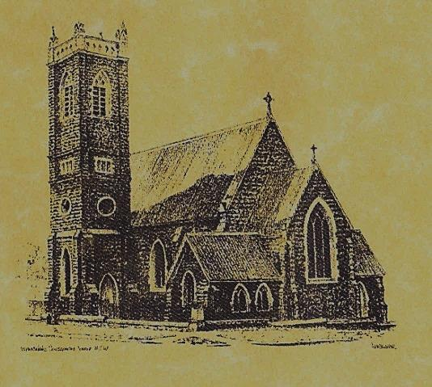

‘CLERGY’
- Fr. Sijo Jose (Parish Priest)
- Fr. Luke Verrell (Assistant Priest)

‘PARISH SECRETARY’
Anna Quinn
Phone: 02 69474599
Fax: 02 69474602
Email: tumut@cg.org.au
Office hours: Wednesday & Friday 9am -12noon
--------------------------------------------------------
‘WEEKEND MASS TIMES’
Saturday Vigil: 6.00pm
Sunday: 10am
Talbingo Sunday: 8.00am
‘THIS WEEKS MASS TIMES’
Tuesday: 6pm
Wednesday: 10am (School Mass)
Thursday & Friday: 8am
Saturday: 9am (every fortnight - Thursday: 11am BUPA Liturgy
Saturday: 9.40am BLAKENEY LODGE Liturgy)
‘ROSARY’
Saturday at 8.45am
Exposition at 8.30am (1st Sat of month)
‘RECONCILIATION’
Saturday at 5.15pm
‘LITURGY MEETING’
Tuesday: 2pm in Chapel
‘PRAYER GROUP’ Wednesday: 2pm in Chapel
---------------------------------------------------------
‘CONTACTS’
Care Group: Anne Huebner 0269473406

Pentecost Sunday Year A
June 4th 2017

Responsorial Psalm

Lord, send out your Spirit, and renew the face of the earth.
Gospel Acclamation

Alleluia, alleluia! Come, Holy Spirit, fill the hearts of your faithful, and kindle in them the fire of your love. Alleluia!

Entrance Antiphon

The love of God has been poured into our hearts through the Spirit of God dwelling within us, alleluia.

Gospel Acclamation
-----------------------------------
Alleluia, alleluia! Tomorrow the wickedness of the earth will be destroyed; the Saviour of the world will be our king. Alleluia!

T THIS WEEK Saturday & Sunday 3rd & 4th June

Ministry | Saturday Vigil 6pm | Sunday 10am
Acolyte | Tony Butler | Dave Shedden
Reader | Rick Hargreaves | Mark Hogan
Commentator | Anita Mason | Pat Spannagle
Children’s Liturgy | ---------- | Caitlin Larter
Musicians | Patricia & Monica | Maureen Norman
Altar Servers | New servers | Chloe Turnbull & Lily Webb
Church Care  ________________________  LINEN Marie Ambrose | Group 3: Yvonne, Lee, Mary Colleen & Kath
NEXT WEEK Saturday & Sunday 10th 7 11th June
Ministry | Vigil 6pm |  | 10am
Acolyte | Christine Kelly |  | Anita Mason
Reader | Dobbie Family |  | Cathy Purcell
Commentator | Dobbie Family |  | Mary Kelly
Children’s Liturgy | ---------- |  | Pat Spannagle
Musicians | Maureen Norman |  | Patricia & Monice
Altar Servers | Ashleigh Oriel & Kayla Crane |  | New servers
Church Care | Group 4: The Dobbie Family
R O S T E R S

FEAST DAY 5th June: Saint Boniface
COLLECTION AMOUNTS FOR MAY 2017
1st $2845.15 2nd $2344.55 D/D $1800.00 Talbingo $112.00 Easter Dues to date $842.95

~PARISH NEWS~
CONFIRMATION this sacrament will be celebrated by Archbishop Christopher Prowse on Friday 16th June 2017 at 6pm. PARISH STREET STALL thank you to all who donated their time to man the stall, donated items to sell and those who baked for the day. A special thanks to Bernie Quilty who supplied a great load of wood for our raffle and to the Falling Leaf Fruit Shop for their generous fruit and veg hamper. Total amount raised was $1666.70. Prize winners were Wood - Julia Gee, Gift voucher - Rod Little and Fruit & Veg - Cheryl Piper, thank you to all for a successful day. STREET STALL CO-ORDINATOR Cathy Purcell is retiring from this position – we would like a kind person to replace her. Our parish registers for 2 street stalls annually, our next stall will be on Friday 18th August 2017. We would like to sincerely thank Cathy for her many years of service to the parish. PASSING OF SR. CLARE FLINN the last Sister of Mercy to leave Tumut, has died in Young this week. A Requiem Mass will be held next Friday in Young. PROJECT COMPASSION BOXES our Tumut community has donated $1406.20 to this appeal. CATHOLIC VOICE June edition has arrived. AUSTRALIAN CATHOLICS please take your copy of the Winter 2017 Parish Edition. SPECIAL THANKS this weekend to our faithful acolyte ~ Dave Shedden ~

We pray for those who have gone before us marked with the sign of faith:

MASS HAS BEEN REQUESTED FOR:

Con & Ennis Twomey, Pauline Shedden, Bob & Sheila Wortes, Robert & Gertrude Tuncks, Ron & Pauline Hamilton, Noel Cook, Hassel McGrath, John Hourigan, Brian Gee, Filomena & Rudi Comai, Alan & Angela Guthrie, Artie & Dulcie Piper ,Tom Kevin Ruben & Harriett Arentz, Kevin Hawthorn, Kevin Marie & Ray Cowan, Russell & Peter Ritchie, Alfred & Bridget Claffey, John Marzol, Ken Gee, Frederick & Mabel McInerney, Ken Elliott, Jock Roberts, Ralph Klaus, Tom & Sam Sturt, Harvey Evans, Chris Ballard, Anna Do, Col Fuller, Emily Fuller, Linda Mulvihill, Stan Kenny, Gus & Kath Clout, Ina Clout, Ab & Mildred Shanahan, Leo Elvie Holt, Terease Lionel Holt, Hugh Oliver, Andrew Jansen, Imelda, Frank & Harriet McInerney, Mick Bristow, Keith Higgins, Kitch Shedden, Arch French, Tom & Dorothy French and James Kelly.

and James Kelly.

