~ GOSPEL REFLECTION ~
Immaculate Conception Parish

P O BOX 600 Tumut
Catholic Community
Collection amounts for January 2016 ~PARISH NEWS~
~ PARISH NEWS ~

Today we are celebrating the ascension of Jesus. Like all of us he departed this life when he died.
It is our faith that he is living in communion of life with God his Father. The Responsorial Psalm (Psalm 47) was composed in ancient Israel for the enthronement of the king.
Today we celebrate the climax of Jesus’ life. At his death he entered into the fullness of communion with God, which we speak of as ‘heaven’, where he became, in the words of the psalm, ‘great king over all the earth’.
Since Easter we have had a period of forty days in which we have been thinking about all the different ways in which Jesus has kept the
promise which he gave his disciples in today’s Gospel: ‘I am with you always, to the end of the age’.
The forty days is itself symbolic of our life’s journey. We know that he will be with us at every stage of our life’s journey.

Today, however, let us begin by forgetting ourselves and just looking at Jesus, and expressing our joy that at the end of his life’s journey,
God raised him to life and took him to himself, into an eternal embrace of love.
We remember that on the day of his resurrection he asked Mary of
Magdala to go and tell Peter and the other apostles: ‘I am ascending to my Father and your Father, to my God and your God’ (John 20:17).
Like us, Jesus spent his life dreaming of this day, his whole being
longing to see God face to face and to enjoy the communion of love for which we are all created and for which we all yearn.

As we love him, so our hearts are happy for him. His time of waiting, his time of suffering is over.
Nothing can ever come between the longing of his heart and the joy of experiencing his hearts’s desire.
An Excerpt by Michael Fallon
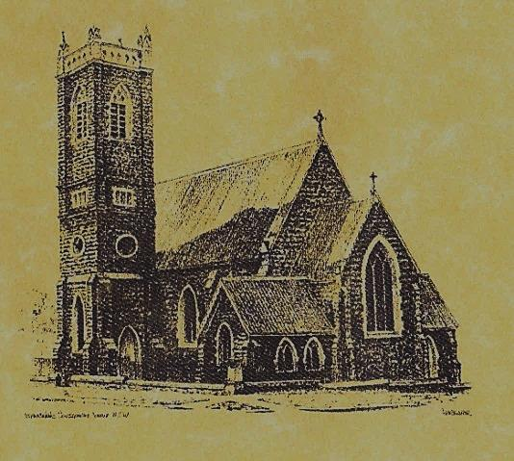

‘CLERGY’
- Fr. Sijo Jose (Parish Priest)
- Fr. Luke Verrell (Assistant Priest)

‘PARISH SECRETARY’
Anna Quinn
Phone: 02 69474599
Fax: 02 69474602
Email: tumut@cg.org.au
Office hours: Wednesday & Friday 9am -12noon
--------------------------------------------------------
‘WEEKEND MASS TIMES’
Saturday Vigil: 6.00pm
Sunday: 10am
Talbingo Sunday: 8.00am
‘THIS WEEKS MASS TIMES’
Tuesday: 6pm
Wednesday: 10am (School Mass)
Thursday & Friday: 8am
Saturday: 9am (every fortnight - Thursday: 11am BUPA Liturgy
Saturday: 9.40am BLAKENEY LODGE Liturgy)
‘ROSARY’
Saturday at 8.45am
Exposition at 8.30am (1st Sat of month)
‘RECONCILIATION’
Saturday at 5.15pm
‘LITURGY MEETING’
Tuesday: 2.00pm in Chapel
‘PRAYER GROUP’ Wednesday: 2pm in Chapel
---------------------------------------------------------
‘CONTACTS’
Care Group: Anne Huebner 0269473406

Gospel Acclamation

Alleluia, alleluia! Go and teach all people my gospel. I am with you always, until the end of the world. Alleluia!

Entrance Antiphon

You kingdoms of the earth, sing to God; praise the Lord, who ascends above the highest heavens; his majesty and might are in the skies, alleluia.
The Ascension of the Lord
May 28th 2017

Responsorial Psalm

God mounts his throne to shouts of joy; a blare of trumpets for the Lord.
Gospel Acclamation
-----------------------------------
Alleluia, alleluia! Tomorrow the wickedness of the earth will be destroyed; the Saviour of the world will be our king. Alleluia!

T THIS WEEK Saturday & Sunday 27th & 28th May

Ministry | Saturday Vigil 6pm | Sunday 10am
Acolyte | Anne Huebner | Peter Malone
Reader | School Mass | Kath Rosetta
Commentator | School Mass | Trish Matthews
Children’s Liturgy | ---------- | Fran Butler
Musicians | Anna Quinn | Patricia & Monica
Altar Servers | Darcy Halloran & Charlotte Kelly | Gabbi & Maggi Dalisay
Church Care  ________________________  LINEN Maria Cobden | Group 2: Cathy, Anna, Pat, Cheryl & Rhonda
NEXT WEEK Saturday & Sunday 3rd & 4th June
Ministry | Vigil 6pm |  | 10am
Acolyte | Tony Butler |  | Dave Shedden
Reader | Rick Hargreaves |  | Mark Hogan
Commentator | Anita Mason |  | Pat Spannagle
Children’s Liturgy | ---------- |  | Caitlin Larter
Musicians | Patricia & Monica |  | Maureen Norman
Altar Servers | New servers |  | Chloe Turnbull & Lily Webb
Church Care | Group 3: Yvonne, Lee, Mary, Colleen, Kath & Brian
R O S T E R S
FEAST DAYS 31st May – The Visitation of the Blessed Virgin Mary 1st June – Saint Justin 3rd June – Saint Charles Lwanga and Companions ~ ~ ~ Ascension Prayer Queen of heaven, rejoice, alleluia. For Christ, your Son and Son of God, has risen as he said, alleluia. Pray to God for us, alleluia. Regina Caeli (12th Century)
~PARISH NEWS~
PREPARATION FOR CONFIRMATION the final information evening will be this Saturday 27th May at 5pm for candidates and parents to attend - followed by the 6pm Vigil Mass presented by the Year 5/6 Class. GOOD SHEPHERD APPEAL 2017 thank you to our generous parishioners, we have forwarded a cheque for $404.40. PROJECT COMPASSION BOXES please bring these in before 31st May 2017. BAPTISM we welcome into our community this weekend Kobe Brad Jelly son of Brad and Allison. We pray for baptism families. AUSTRALIAN CATHOLICS please take your copy of the Winter 2017 Parish Edition. WEEK OF PRAYER FOR CHRISTIAN UNITY 28th May to 4th June 2017. The Baptist Church will be hosting a reconciliation on Sunday 4th June at 6.30pm followed by supper. Everyone welcome. NSW HERITAGE MONTH – Historic Saint Patrick’s Church Gundagai (1885). First Catholic Church for Gundagai was 1854 and Lanigan Abbey Estate 1888 (former Catholic Convent and school). Come and visit these buildings this weekend from 11am to 3pm. For more information contact Joan and Brian Tozer on 69442852 or 0410633745. SPECIAL THANKS to our McAuley students and teachers for presenting the Vigil Mass this weekend.

We pray for those who have gone before us marked with the sign of faith:

MASS HAS BEEN REQUESTED FOR:

Con & Ennis Twomey, Pauline Shedden, Bob & Sheila Wortes, Robert & Gertrude Tuncks, Ron & Pauling Hamilton, Noel Cook, Hassel McGrath, John Hourigan, Brian Gee, Filomena & Rudi Comai, Alan & Angela Guthrie, Artie & Dulcie Piper ,Tom Kevin Ruben & Harriett Arentz, Kevin Hawthorn, Kevin Marie & Ray Cowan, Russell & Peter Ritchie, Alfred & Bridget Claffey, John Marzol, Ken Gee, Frederick & Mabel McInerney, Ken Elliott, Jock Roberts, Ralph Klaus, Tom & Sam Sturt, Harvey Evans, Chris Ballard, Anna Do, Col Fuller, Emily Fuller, Linda Mulvihill, Stan Kenny, Gus & Kath Clout, Ina Clout, Ab & Mildred Shanahan, Leo Elvie Holt, Terease Lionel Holt, Hugh Oliver, Andrew Jansen, Imelda, Frank & Harriet McInerney, Mick Bristow, Keith Higgins, Kitch Shedden, Arch French, Tom & Dorothy French, Kay & Andy Bulman and James Kelly.

and James Kelly.

