Let us introduce……..
Sue Bulger
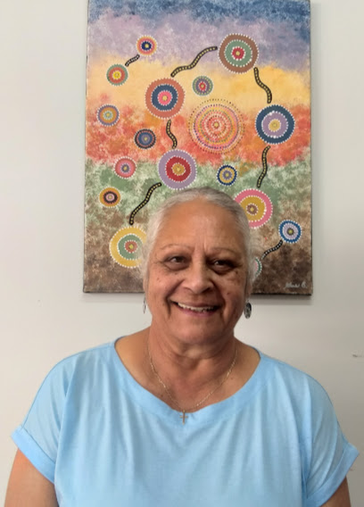
Sue was born in Gundagai, the eldest girl of a family of eleven children. She lived at Brungle then moved to live at Gilmore when her Father, Vince, was working as a fettler on the Railway. Sue attended Tumut Public School, then Tumut High School and loved sport and reading. From Tumut Sue went to train as a General Primary teacher at Signadou Dominican Catholic Teachers College in Watson ACT. After spending five years away training, then short times teaching in Canberra and Cootamundra, Sue came to teach at St Patricks Primary School in Gundagai for 13 years. From Gundagai Sue taught at St Brigid’s Catholic School in Tumut.
After 30 years Sue stopped teaching and in 2015 became the CEO for the Brungle-Tumut Local Aboriginal Land Council, a position she resigned from in March 2023. She completed a Graduate Certificate 4 through Charles Sturt University, Wagga, in Wiradjuri Language Heritage and Culture, a course which four of her sisters have also completed.
Sue is an active member of Tumut Catholic Church Community and loves attending Mass on a Sunday. Currently she serves as an Acolyte, Reader, is a member of the Parish Finance Committee. She misses her connection to the Mercy Sisters (in particular Sisters Celine, Kathleen, Marguerita and Maureen Hummerston) who did so much for the local Aboriginal community and prepared them for the sacraments.
Presently Sue is Vice President of the Tumut St Vincent de Paul Conference, is teaching Wiradjuri language at Tumut Pre School and she is facilitating the Burrabinya Girls Aboriginal program for years 7-8-9 at Tumut High School through Compact which concentrates on careers. These days she is known as Aunty Sue , an Elder of the Wiradjuri Brungle Tumut Community.
PARISH PASTORAL COUNCIL NEWS
The Parish Pastoral Council is scheduled to meet on the following dates throughout 2023.
- 10th May
- 26th July
- September (date to be advised)
- 8th November
- 6th December
If you have any Parish matters to be discussed, please speak to, or provide written information to any of the Parish Councillors (listed below) two weeks prior to the meeting date.

MUSIC LITURGY
Our parish is blessed with choice for our music Liturgy. We have four wonderful groups of Parishioners willing to share their talents and gifts with us.
Thank you Patricia Mangelsdorf and Monica Webb, Marty and Lisa Pannell, Francis Moreno and Prince Paradero, Felicity and Patrick McCabe.
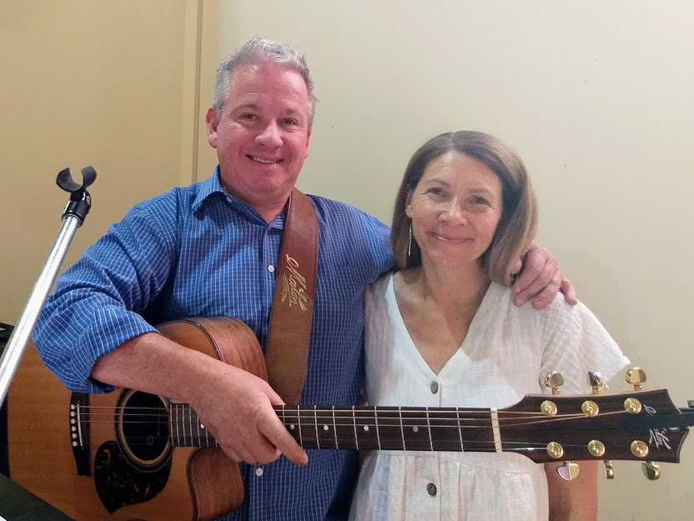
Lisa & Marty Pannell
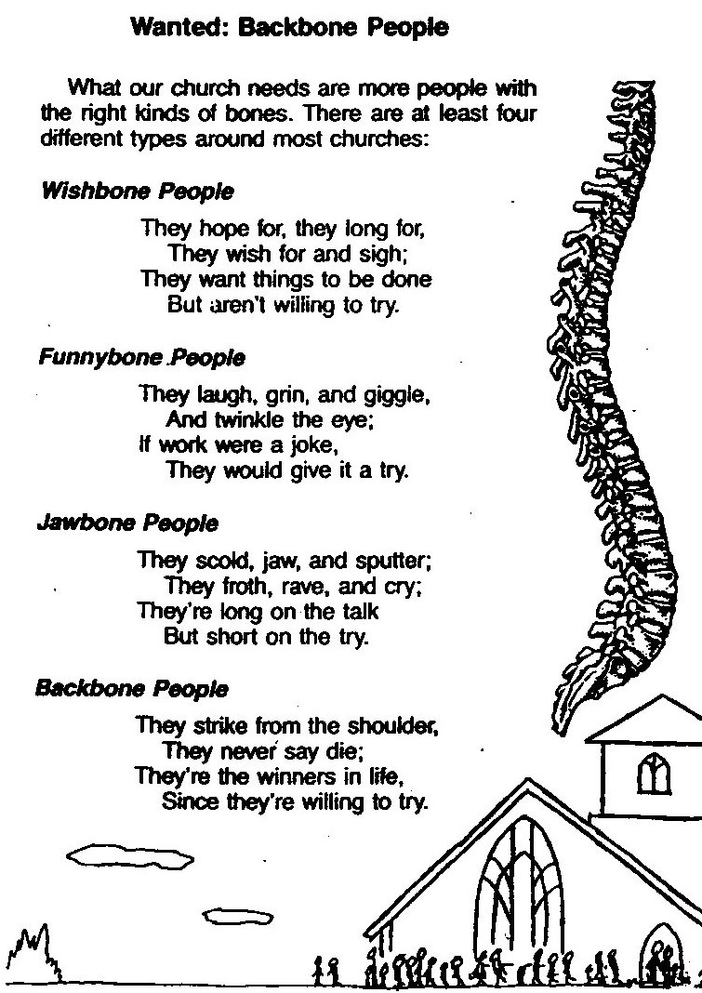
Laugh Along……….. Three pensioners, each with a hearing loss, were playing golf one fine March day.
One remarked to the other, “Windy, isn’t it?”. “No, “ the second man replied, “it’s Thursday”
And the third man chimed in, “So am I. Let’s have a beer”

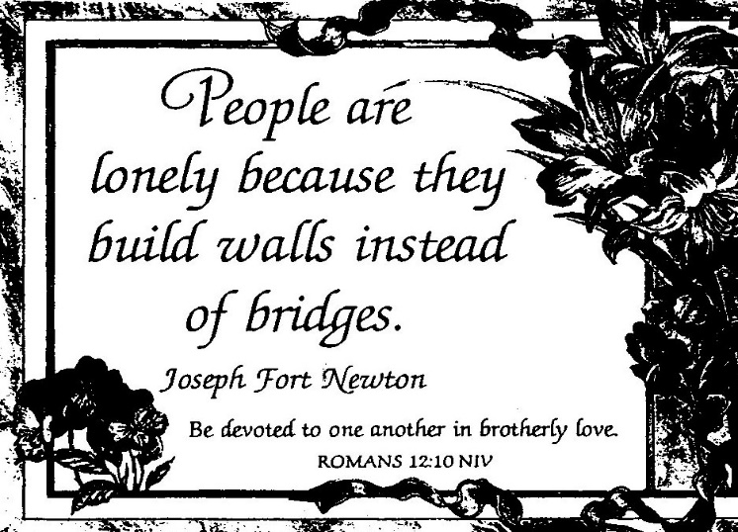
WHS REPORT
I began my role as Work Health and Safety Officer after inductions by Victor Dunn on 21 October 2018. During the years following I have seen to the repairing or replacing of many items and parts of the buildings in the Immaculate Conception Church, Saint Mary’s Hall and the Parish Office. Recently I have covered all the items on the Safety Check list and have patiently worked my way through a five page list. I feel very confident that the buildings in my care are safe and well maintained in this field.
Some of the jobs include, new stairs to the gallery, first aid kit, smoke alarms, covers on power points, steeple check, hooks on the kneelers to prevent shin damage, fire extinguisher checks and all electrical items and power points checked. I feel very proud of the maintenance I have arranged and happy that our congregation is safe. We can all pray in peace.
Trish Matthews, WH & S Officer
