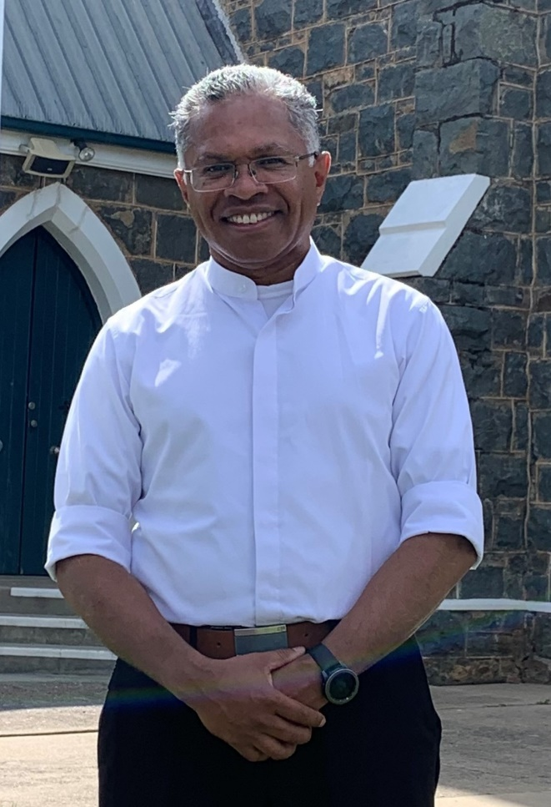
Father Joseph Neonbasu
We welcome Father as the new Parish Priest
of the Tumut Mission
The Journey of my life
I was born in Indonesia. I am from 8 children, 4 out of 8 are priests (3) and a Private Vows Professed Nun. I wanted to become priest before I went to School. I started the training to be a priest when I was 15 years old at the Minor Seminary. After 4 years, I went to the Major Seminary in Indonesia for another 6 years.
I came to Australia to continue my studies in February 2003. I spent another 5 years for further studies here in Australia (2 years in Canberra and 3 years in Melbourne). I was ordained as a priest in Canberra on 12th December 2009 by Archbishop Mark Coleridge. I served as an assistant at St.

Benedict’s Parish in Narrabundah, in Canberra for a year.
In January 2011, I was sent to Darwin. I served at St. Martin de Porres Catholic Aboriginal Community in Darwin for 3 years. Then I took the chaplaincy at St John’s Catholic College in Darwin for 2 years while doing the Hospital chaplaincy at Royal Darwin Hospital. In January 2015, I was appointed as the Parish Priest at Holy Spirit’s Parish in Casuarina in Darwin.
On my 10th anniversary, I had an opportunity to have a sabbatical in 2019. I did a course in Italy for 4 months. While in Europe, I was able to walk the Camino de Santiago, from a little town in France, St Jean Pied de Port to Compostela in Spain for 31 days (825km). Then I went to Philippines doing another course at Ateneo University in Manila for 5 months.
After my sabbatical year, I went to Melbourne for 6 months at St Benedict’s Parish in Burwood. Then I moved to Canberra. I spent 2 months at St Anthony of Padua’s Parish in Wanniassa, then 1 year in Young Mission and one year in Goulburn Mission. I was appointed as the Parish Priest of Tumut Mission in January 2023.
Content supplied and printed with permission of Fr Joseph

WORLD DAY OF PRAYER – 2023
World Day of Prayer in Tumut was celebrated at All Saints Anglican Church on 3rd March at 7pm. The service had been prepared by the women of Taiwan. It was pleasing to see a good representation of members of our Catholic Community participate.

PARISH FINANCES
Our Parish has buildings and infrastructure which require ongoing maintenance & upkeep. Planned giving is a tangible way that parishioners can assist in maintaining our Church, St Mary's Hall & the Parish house.

SACRAMENT OF HOLY COMMUNION
“For whenever you eat this bread and drink this cup, you proclaim the Lord’s death until he comes.” ~1 Corinthians 11:26
The Ceremony takes place on Wednesday 22nd March
Throughout this term our Year 4 have been preparing for this very special Sacrament of Initiation. Please keep these students and their families in your prayers
Let us pray. Dear God, we ask your blessing on the children preparing for their first Holy Communion. We asked your blessing too on their families. May the Body and Blood of Jesus nourish them so that they may live as your followers. We ask this prayer through your Son, Jesus Christ, our Lord. Amen
MORNING TEA
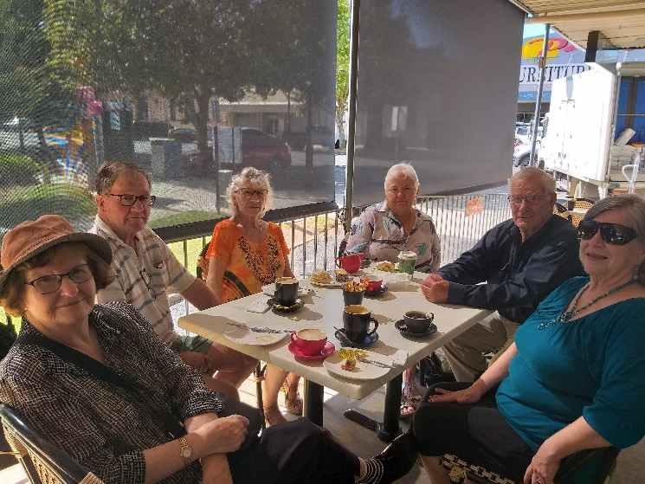
Enjoying great company and yummy food at Pie in the Sky Bakery, held on 1st Friday of each month at 10.30 a.m. – Come along and join in. Note: For April only it will be held on the 2nd Friday because of Good Friday.
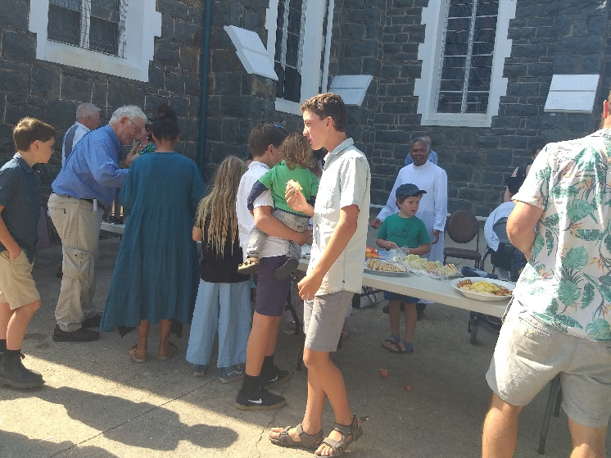
Morning Tea is held on the 1st Sunday of the month after 10 a.m. Mass
Great way to build community

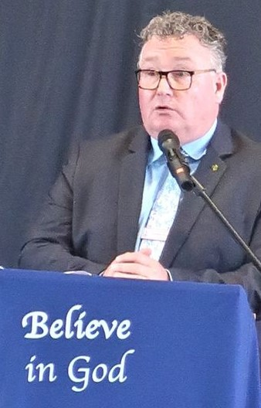
Eamonn Moore, Principal

McAuley Catholic Central School
celebrated their Opening School Mass on Wednesday, 15th February. They were able to gather for the first time as a K – 12 school.
The Mass was a great beginning to the school year where the Student Representative Council for 2023 were formally commissioned.
Many thanks to Catholic Education Canberra Goulburn Director Mr Ross Fox, other special guests and parents for attending.
Content and permission provided by E. Moore

EUCHARISTIC MINISTRY
You may be aware of parishioners who are housebound, in Care or unwell. Contact either Anne Huebner, Anita Mason, Father Joe (Details on Bulletin) or complete a card at the back of the Church. A visit and/or communion can be arranged. If you would like to be part of this wonderful ministry please offer your services.

Parish Facebook Page
Did you know that the parish has a Facebook page. For parishioners who are Facebook users this is another way of staying connected and finding out what is happening in your Parish. If you want to submit an item you must either email or speak to Father or Sue to get it included.
Facebook: Immaculate Conception Tumut Parish

