Our Lady Star of the Sea – Narooma
9 Canty St, Narooma

St Mary’s – Cobargo/ Bermagui
Parish Priest: Fr Joe Tran
jotran53@yahoo.com.au
Parish Secretary: Suzanne Voytas
PO Box 50, Narooma 2546 ph; 02 4476 2191

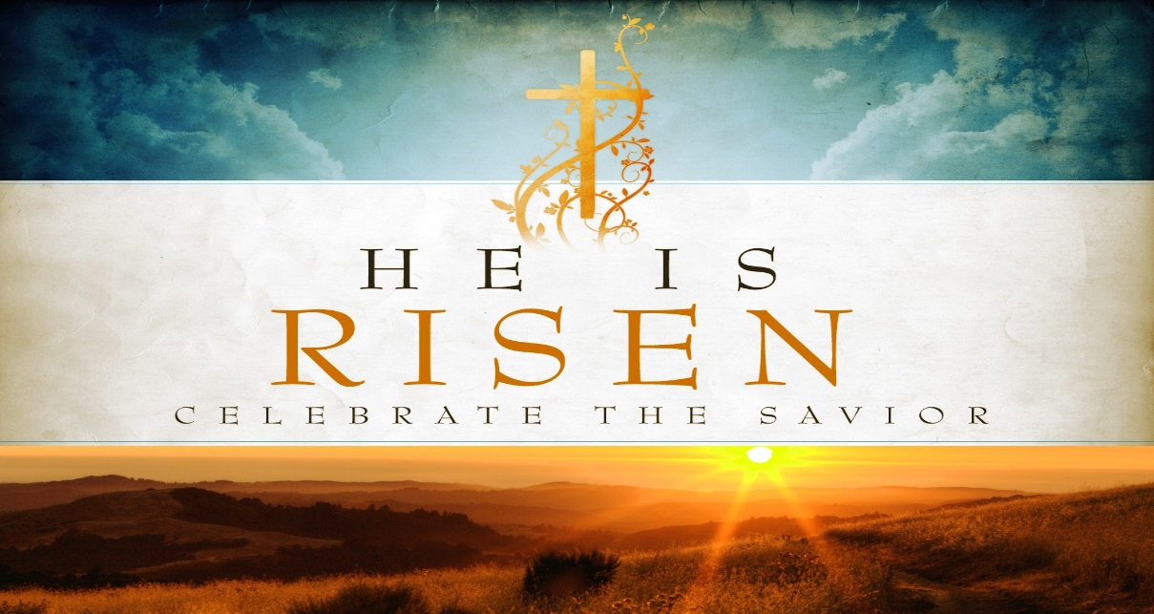

3rd May 2020 Year A: The Shepherd And Guardian Of Our Souls: Today we rejoice in the Lord, our Shepherd, who calls us to himself.
THOMAS MERTON
“Solitude is so necessary both for society and for the individual that when society fails to provide sufficient solitude to develop the inner life of the persons who compose it, they rebel and seek false solitudes”.

PRAYER in this TIME of CRISIS

Almighty and all-merciful God,
Lover of the human race, healer of all our wounds,
In whom there is no shadow of death,
Save us in this time of crisis:
Grant wisdom and courage to our leaders;
Watch over all medical people
As they tend the sick and work for a cure;
Stir in us a sense of solidarity beyond all isolation;
If our doors are closed, let our hearts be open.
By the power of your love destroy the virus of fear,
That hope may never die
And the light of Easter, the triumph of life,
May shine upon us and the whole world.
Through Jesus Christ, the Lord risen from the dead
Who lives and reign for ever and ever.
Amen
Holy Mary, health of the sick, pray for us
St Joseph, guardian of us all, pray for us.

NADA, NADA, NADA
These words are familiar to St John of the Cross, a Spanish Carmelite Monk of the sixteenth century. These words mean, “nothing, nothing, nothing.” It reflects a reality of emptiness, of life when one faces it in a situation of loss, pandemic, even death. It also echoes a spiritual journey that aims to get something beyond a physical world, God’s glory world.
He once said:
“To come to savour all, seek to find savour in nothing;
To come to pocess all, seek pocession in nothing,
To come to be all, seek in all to be nothing.”

We have been living in the pandemic lockdown for the last five weeks, a situation that the world has not been in before. Physically and mentally we had no choice but put the word “Nada” into real life. It offers us a real chance to face and to touch what is most important in life. When physical activities are quietened, own mental lives have a chance to grow. One of many suggestions that one can do is to do a retreat, a kind of reflection on a particular point or area of life that one can renew it, strengthen and grow. If you need any help you can talk to Fr Joe (4476 2191)

Dear Parishioners
We continue with all churches closed. It is a challenge but is also an opportunity for us to discover some good things to do in our free time.

Spiritual exercises:
- Mass on line; catholicvoice.org.au or
cgcatholic.org.au
- Spend sometime with the Lord in the church, on your own or with your partner (ask for a key if you want one)
- Spiritual reading – some books are available in church foyer for you to borrow
Physical/Mental exercises
- Walking, gardening, cooking
- Phoning a friend and family
- Art works – painting, writing, knitting (squares), sewing
Balancing our mental health and physical health through this challenge is necessary.
KEEP WELL

MARIAN MONTH of MAY
Traditionally May is dedicated to Mary our Mother. It is a good opportunity to ask our Mother to bless the world and to secure us from the pandemic of the Wuhan virus.

MARIAN PROCESSION at COBARGO
Fr Martins from Batemans Bay will lead an adoration and the Rosary at Cobargo Church at 2pm on Sunday 3rd May.
Please join him for this adoration and pray for the pandemic.

LINK ON EMAIL – FIND EMAIL

ZOOM MEETING
We need someone who knows how to organise a Zoom meeting to volunteer to help us. This would be a wonderful way to maintain face to face communications and create a social life amongst us.
A great idea would be to create a parish social night for everyone to join together on Zoom, dress up, with music (guitars?) with self-served drinks and dinner. We can share our laughter, smiles and talk to each other.
Attached is a copy of the Zoom instructions.
Once we are familiar with the procedures, we will confirm a date. Look forward to seeing you then.

FINANCE COLLECTIONS
As previously explained in the email on 22nd April, the Archdiocese has streamlined the electronic banking procedures for both collections. This is called the CDF Bpoint Giving Page
http://www.bpoint.com.au/pay/CATHOLICDEVELOPMENTFUNDARCHDIOCEOFCANBERRA
This facility is available for those wishing to pay their contribution directly into the accounts for either the 1st or 2nd collections.

1. Central Presbytery Fund noting the donor name and Parish, or
2. Parish account noting donor name and Envelope number (if provided).
Good Shepherd Sunday has been added to the selections on the giving page.

However, there are alternative ways to contribute, either by
By placing an envelope under the church door -either and/or a plain envelope for 1st collection and your planned giving envelope. Please place the whole month’s donation in ONE envelope.
Please clearly mark any plain envelopes with the intention of your donation, ie 1st or 2nd collection.
If your contribution is for 1st collection include your parish’s name, ie Narooma, Cobargo or Bermagui.
Also you might prefer to post a cheque to Narooma Parish, PO Box 50, Narooma. 2546
Thank you very sincerely for your support.
Unfortunately Suzanne will not be in the parish office for the next two weeks..

For your understanding of the purpose of the collections -

THE FIRST COLLECTION

Central Presbytery Fund account for the
Catholic Archdiocese of Canberra and Goulburn

• Priests in parishes where the first collection
is insufficient to meet their stipend
• The support of the Archbishop, Vicar General
and Chancellor
• Priests in remote dioceses across Australia
• Clergy Retirement Foundation (in support of
sick and retired clergy)

THE SECOND COLLECTION-
Planned giving envelopes

This is for the maintenance and growth of our parish’s mission. For example

• Liturgical needs
• Salaries
• Utilities
• Resources
• Maintenance of schools and churches
• Repayment of loans
• Parish sacramental formation and pastoral
programs

Do you have any stories or jokes to share. Please let us know email: narooma@cg.org.au

Suzanne Voytas, our secretary, suffered a mild heart attack last Saturday. She was transferred to Woden Hospital and was treated well. She had one stint inserted and is now back home doing very well. God bless and take care. You are in our love and prayers.

Please pray for the sick: Jennie Gahan, Rita Winkler, Shirley Fogwell, Brian Wyndham, Howard Emanuel, Eric Niemoeller
The recently deceased: Assunta Camilleri, Lorna Welsh, Dale Bersley, Con Reen, Nola Sutherland, Nancy Langsam
Anniversaries: David Cowan, Ignacio & Teodosia Sab, Pedro de Chavez,, Jaime Rosales, RobynStevens, May Lazzaro, Fr Leo Stevens
Please keep them and their families in our prayers.

GOD BLESS

