Our Lady Star of the Sea – Narooma
9 Canty St, Narooma

St Mary’s – Cobargo/ Bermagui
Parish Priest: Fr Joe Tran
jotran53@yahoo.com.au
Parish Secretary: Suzanne Voytas
PO Box 50, Narooma 2546 ph; 02 4476 2191

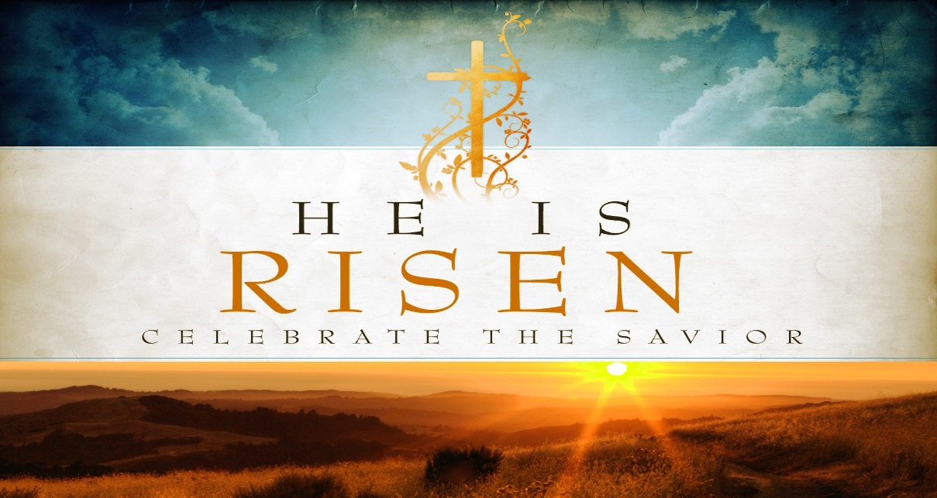

26th April 2020 Year A: Christ With Us on the Way of Life: Christ has made known to us the true way of life and ransomed us from the useless way of life handed down to us. He is with us today in the breaking of bread.
THOMAS MERTON
“Solitude is so necessary both for society and for the individual that when society fails to provide sufficient solitude to develop the inner life of the persons who compose it, they rebel and seek false solitudes”.

PRAYER in this TIME of CRISIS

Almighty and all-merciful God,
Lover of the human race, healer of all our wounds,
In whom there is no shadow of death,
Save us in this time of crisis:
Grant wisdom and courage to our leaders;
Watch over all medical people
As they tend the sick and work for a cure;
Stir in us a sense of solidarity beyond all isolation;
If our doors are closed, let our hearts be open.
By the power of your love destroy the virus of fear,
That hope may never die
And the light of Easter, the triumph of life,
May shine upon us and the whole world.
Through Jesus Christ, the Lord risen from the dead
Who lives and reign for ever and ever.
Amen
Holy Mary, health of the sick, pray for us
St Joseph, guardian of us all, pray for us.

Dear Parishioners
We continue with all churches closed. It is a challenge but is also an opportunity for us to discover some good things to do in our free time.

Spiritual exercises:
- Mass on line; catholicvoice.org.au or
cgcatholic.org.au
- Spend sometime with the Lord in the church, on your own or with your partner (ask for a key if you want one)
- Spiritual reading – some books are available in church foyer for you to borrow
Physical/Mental exercises
- Walking, gardening, cooking
- Phoning a friend and family
- Art works – painting, writing, knitting (squares), sewing
Balancing our mental health and physical health through this challenge is necessary.
KEEP WELL

DEAR FRIENDS
We are in the fourth week of “fasting’ not gathering for our Sunday Eucharist, not smiling at each other on the church ground, not singing our hearts out to thank God for life and love, not talking and laughing over a cup of coffee.. We absolutely miss the physical contact with each other so much.
This quarantine time though can offer us something that our normal ordinary time really cannot, that is our solitude, our inner life that awaits us to dialogue with God and self before engaging with others. In fact the present pandemic shows us that convincing reality.
We have been in a reality of emptiness of our inner life for the last couple of weeks of the quarantine. It now reveals a master key to open our inner life house so we can talk, dialogue with God and your true self. We can discover God’s grace and blessings in and through in everything, even simple and ordinary things like air and water, let alone your husband or your wife, parents and children, friends and me.
May our Lord bless you and your families with abundant blessings of Easter peace and joy. I would like to use St Paul’s words to let you know from the bottom of my heart: “ I thank my God each time I think of you and when I pray for you, I pray with joy.” ( Philippians 1:3-4)

MARIAM MAY PROCESSION
Due to the Wuhan virus, our annual Mariam Procession at Cobargo for this year will be cancelled. Instead each parish of the Coastal Deanary is encouraged to have adoration and rosary at its local church at 2.00pm, Sunday 3rd May 2020.Priests wil arrange appropriate online adoration on the Zoom meeting channel.
Our Parish – Narooma will try our best to use the Zoom meeting to post online the adoration on that day. Will confirm this in our next bulletin.

ZOOM MEETING
We need someone who knows how to organise a Zoom meeting to volunteer to help us. This would be a wonderful way to maintain face to face communications and create a social life amongst us.
A great idea would be to create a parish social night for everyone to join together on Zoom, dress up, with music (guitars?) with self-served drinks and dinner. We can share our laughter, smiles and talk to each other.
Attached is a copy of the Zoom instructions.
Once we are familiar with the procedures, we will confirm a date. Look forward to seeing you then.

TELEPHONE TREE – The telephone is the most common means of communication so we can easily create a tree with two or three branches. That means if you pick one person as your 1st choice to talk regularly, then that person would ring another to talk to more regularly. If it works that would give us a support network and encourage us to support each other.

FINANCE COLLECTIONS
As previously explained in the email on 22nd April, the Archdiocese has streamlined the electronic banking procedures for both collections.
However, there are alternative ways to contribute, either by
By placing an envelope under the church door -either and/or a plain envelope for 1st collection and your planned giving envelope. Please place the whole month’s donation in ONE envelope.
Please clearly mark any plain envelopes with the intention of your donation, ie 1st or 2nd collection.
If your contribution is for 1st collection include your parish’s name..
Thank you very sincerely for your support.
However, if you are not comfortable with any of these arrangements, I will be in the Parish office on Friday afternoons between 1- 3 pm. Please knock on the door, leave your envelopes in the basket and I will collect but still keeping safe distancing.

For your understanding of the purpose of the collections -

THE FIRST COLLECTION

Central Presbytery Fund account for the
Catholic Archdiocese of Canberra and Goulburn

• Priests in parishes where the first collection
is insufficient to meet their stipend
• The support of the Archbishop, Vicar General
and Chancellor
• Priests in remote dioceses across Australia
• Clergy Retirement Foundation (in support of
sick and retired clergy)

THE SECOND COLLECTION

This is for the maintenance and growth of our parish’s mission. For example

• Liturgical needs
• Salaries
• Utilities
• Resources
• Maintenance of schools and churches
• Repayment of loans
• Parish sacramental formation and pastoral
programs

AN INSPIRING STORY
An old man recovered from the devastating illness of the Wuhan virus and was being discharged from hospital. A nurse asked him to pay for the cost of using the oxygen equipment. The man burst into tears. Presumably he was shocked with the cost, the nurse told him he shouldn’t be worried if he wasn’t able to pay for it. Wiping his tears he said, “no, no I am not worry about the money, I have money. But I cried because I have been breathing air for 90 years for absolutely free but I took it for granted. Now this illness of the virus teaches me that I had lost some part of my inner life for so long. He gives a big smile and thanks God and the doctors and nurses that gave him back his breathing life! Alleluia !!!!

Do you have any stories or jokes to share. Please let us know email: narooma@cg.org.au

Please pray for the sick: Jennie Gahan, Rita Winkler, Shirley Fogwell, Brian Wyndham, Howard Emanuel, Eric Niemoeller
The recently deceased: Assunta Camilleri, Lorna Welsh, Dale Bersley, Con Reen, Nola Sutherland, Nancy Langsam
Anniversaries: David Cowan, Ignacio & Teodosia Sab, Pedro de Chavez,, Jaime Rosales, RobynStevens, May Lazzaro
Please keep them and their families in our prayers.

GOD BLESS

