Our Lady Star of the Sea – Narooma
9 Canty St, Narooma

St Mary’s – Cobargo/ Bermagui
Parish Priest: Fr Joe Tran
jotran53@yahoo.com.au
Parish Secretary: Suzanne Voytas
PO Box 50, Narooma 2546 ph; 02 4476 2191

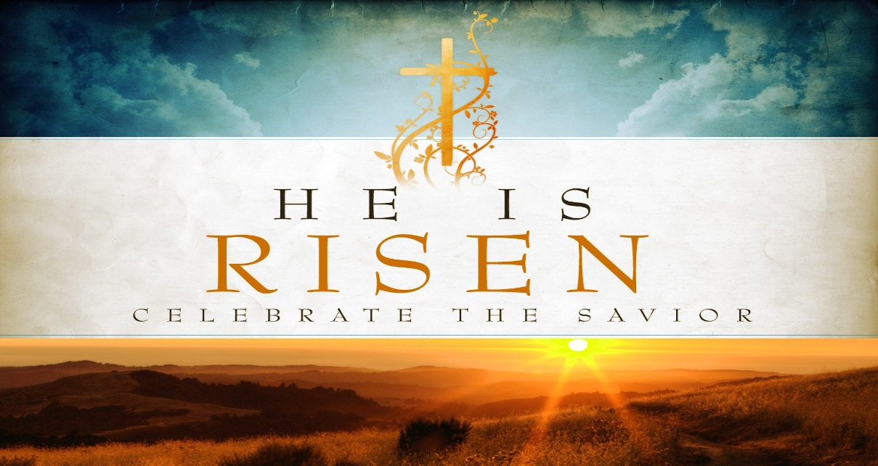

19th April 2020 Year A: Our Easter Joy: Today as we hail Christ as our Lord and God we are filled with the joy of the disciples in seeing the risen Lord. In this season of renewal, we are like those early Christians who were ‘filled with a joy so glorious that is cannot be described’.
DEVINE MERCY SUNDAY – prayers at 3pm every day for a cure for Covid19
THOMAS MERTON
“Solitude is so necessary both for society and for the individual that when society fails to provide sufficient solitude to develop the inner life of the persons who compose it, they rebel and seek false solitudes”.

PRAYER in this TIME of CRISIS

Almighty and all-merciful God,
Lover of the human race, healer of all our wounds,
In whom there is no shadow of death,
Save us in this time of crisis:
Grant wisdom and courage to our leaders;
Watch over all medical people
As they tend the sick and work for a cure;
Stir in us a sense of solidarity beyond all isolation;
If our doors are closed, let our hearts be open.
By the power of your love destroy the virus of fear,
That hope may never die
And the light of Easter, the triumph of life,
May shine upon us and the whole world.
Through Jesus Christ, the Lord risen from the dead
Who lives and reign for ever and ever.
Amen
Holy Mary, health of the sick, pray for us
St Joseph, guardian of us all, pray for us.

HAPPY EASTER
Easter celebrations in the midst of the Wuhan virus pandemic carries a very different atmosphere. We are confined to our homes but in spirit join not only with our local church but the whole universal church to contemplate and celebrate the mystery of the life and death of Our Lord and that of our own. Thousands of young and old have been through this mystery during the pandemic. Their deaths reawaken our lives. What is most important in life?
Faith leads us to our belief that is God who is most central of all. Everything will pass away including our lives but only and only God alone is ever-lasting life.

“Nada Te Turbe” is a Taize song based on St Teresa of Avila’s words: Nada te turbe, nada te espante …….
Solo Dios basta.
“Nothing disturbs you, nothing frightens you, ….God alone is sufficient.”
I strongly recommend that you listen to this online.

May the Lord’s resurrection give us hope and strength to go through this rough time. Keep safe and Happy Easter to you and your family.
GOD BLESS

NAROOMA CHURCH SANITIZATION OF DOORS -We need to spray and wipe the Church doors weekly. If you can help with this, please give Fr. Joe a call. Thank you very much.

Dear Parishioners
We continue with all churches closed. It is a challenge but is also an opportunity for us to discover some good things to do in our free time.

Spiritual exercises:
- Mass on line; catholicvoice.org.au or
cgcatholic.org.au
- Spend sometime with the Lord in the church, on your own or with your partner (ask for a key if you want one)
- Spiritual reading – some books are available in church foyer for you to borrow
Physical/Mental exercises
- Walking, gardening, cooking
- Phoning a friend and family
- Art works – painting, writing, knitting (squares), sewing
Balancing our mental health and physical health through this challenge is necessary.
KEEP WELL

DEAR FRIENDS
We are in the third week of “fasting’ not gathering for our Sunday Eucharist, not smiling at each other on the church ground, not singing our hearts out to thank God for life and love, not talking and laughing over a cup of coffee.. We absolutely miss the physical contact with each other so much.
This quarantine time though can offer us something that our normal ordinary time really cannot, that is our solitude, our inner life that awaits us to dialogue with God and self before engaging with others. In fact the present pandemic shows us that convincing reality.
We have been in a reality of emptiness of our inner life for the last couple of weeks of the quarantine. It now reveals a master key to open our inner life house so we can talk, dialogue with God and your true self. We can discover God’s grace and blessings in and through in everything, even simple and ordinary things like air and water, let alone your husband or your wife, parents and children, friends and me.
May our Lord bless you and your families with abundant blessings of Easter peace and joy. I would like to use St Paul’s words to let you know from the bottom of my heart: “ I thank my God each time I think of you and when I pray for you, I pray with joy.” ( Philippians 1:3-4)

FINANCE COLLECTIONS
We do need to try and maintain our financial assistance to the church collections – 1st and 2nd collections, as life does go on. There are two ways you can continue to provide your contributions. However, many parishioners have found that by creating a direct debit from either your debit card or credit card is a much easier and safer way.
- Direct debit into one of the following accounts
- First collection Central Presbytery Account
BSB; 062 786
Account; 000029248
Reference: PARISH SURNAME eg, Narooma Voytas
It is very important that individuals put the reference information in, so that your donation can be correctly allocated to your parish.

- Second collections …… Our Lady Star of the Sea
BSB; 062 902
Account ; 10123576
Reference; NAME or Envelope No

Cobargo/Bermagui St Mary
BSB; 062 902
Account; 10123576
Reference: Name or Envelope No

- By placing an envelope under the church door -either and/or a plain envelope for 1st collection and your planned giving envelope. Please place the whole month’s donation in ONE envelope.
Please clearly mark any plain envelopes with the intention of your donation.
Thank you very sincerely for your support.

VISITATIONS TO THE HOUSEBOUND
Following the protocols issued by the Archdiocese – All housebound visitation for the distribution of Holy Communion is suspended until further notice.
In case of an emergency you can contact Fr Joseph – 44762191 for anointing. Please make sure you have put on a mask and sanitized your hands before receiving the sacrament. If you carry the Wuhan virus you have to self-quarantine and the priest can give you a blessing from outside.

ONLINE EXPERT NEEDED
We want to look at how to link up between parish members and what channel is easy for everyone to use. Please call Fr Joe if you can provide assistance – Facebook/Facetime or Zoom meetings are good one but connection in groups is something we need to know how to do it.

TELEPHONE TREE – The telephone is the most common means of communication so we can easily create a tree with two or three branches. That means if you pick one person as your 1st choice to talk regularly, then that person would ring another to talk to more regularly. If it works that would give us a support network and encourage us to support each other.

AN INSPIRING STORY
An old man recovered from the devastating illness of the Wuhan virus and was being discharged from hospital. A nurse asked him to pay for the cost of using the oxygen equipment. The man burst into tears. Presumably he was shocked with the cost, the nurse told him he shouldn’t be worried if he wasn’t able to pay for it. Wiping his tears he said, “no, no I am not worry about the money, I have money. But I cried because I have been breathing air for 90 years for absolutely free but I took it for granted. Now this illness of the virus teaches me that I had lost some part of my inner life for so long. He gives a big smile and thanks God and the doctors and nurses that gave him back his breathing life! Alleluia !!!!

Do you have any stories or jokes to share. Please let us know email: narooma@cg.org.au

Please pray for the sick: Jennie Gahan, Rita Winkler, Shirley Fogwell, Brian Wyndham, Howard Emanuel, Eric Niemoeller
The recently deceased: Assunta Camilleri, Norma McVeigh, Lorna Welsh, Dale Bersley, Con Reen
Anniversaries: David Cowan, Ignacio & Teodosia Sab, Pedro de Chavez,, Jaime Rosales, RobynStevens, May Lazzaro
Nola Sutherland from Cobargo and Nancy Langsam from Dalmeny passed last week.
Please keep them and their families in our prayers.

GOD BLESS

